## Visoka skola strukovnih studija za informacione i komunikacione tehnologije

**Discover Universe**

<https://zarke998.github.io/discover-universe>

## Smer: Internet tehnologije Modul: Web programiranje Predmet: Web programiranje 1

Andrej Zarkovski 22/18

**Sadržaj**

1. Uvod 2
   1. Korišćeni programski jezici 2
   2. Opis funkcionalnosti 3
2. Organizacija 7
   1. Organizaciona šema 7
   2. Mapa sajta 7
   3. Opis stranica sajta 9
      1. index.html 9
      2. games.html 11
      3. about.html 12
3. Kodovi 13
   1. HTML 13
      1. index.html 13
      2. games.html 15
      3. about.html 18
   2. CSS 20
      1. style.scss 20
      2. style.css 30
   3. JavaScript 32
      1. mainIndex.js 32
      2. mainGames.js 33
      3. animacijeIndex.js 38
      4. formCheck.js

# Uvod

* 1. **Korišćeni programski jezici**

Za izradu sajta korišćene su sledeće tehnologije:

* + - HTML 5
    - CSS 3/ SASS
    - Materialize
    - Bootstrap
    - JavaScript
    - jQuery
    - jQuery plugin – Animate Scroll
    - Visual Studio Code
    - Photoshop
  1. **Opis funkcionalnosti**

Sajt poseduje sledeće funkcionalnosti:

* + - Dinamičko učitavanje navigacije na svakoj strani (takodje i side navigacije kada se dodje ispod 992px)
    - Pojavljivanje strelice za povratak na vrh strane nakon skrolovanja stranice na dole na svim stranama
    - Dinamičko učitavanje i zatim menjanje pozadinske slike i h2 taga svaki put kada se osveži stranica
    - Dinamičko učitavanje artikala u prvoj sekciji na strani index
    - Dinamicko ispisivanje blokova na strani games.html, a potom dodavanje po jos 2 bloka svaki put kada se klikne na dugme ,,More games,,
    - Dimanicko ispisani blokovi za papir, kamen, makaze i naravno funkcionalna igra za papir, kamen, makaze
    - Smanjivanje visine navigacije na ekranima vecim od 992px kada se skroluje vise od 50 px na dole, i vracanje u prvobitnu visinu kada se skroluje ispod 50px od vrha stranice.
    - Detaljna provera tacnosti forme (tekst za greske se ispisuje ispod svakog polja koje nije dobro popunjeno, polje drzi na sebi crveni border sve dok korisnik ne unese podatke u pravilnom formatu i izadje iz polja, tada postaje zeleno, u slucaju da se ne slaze sa regularnim izrazom, i dalje je crveno. Selekcijom nekog tipa igrice iz Game Type select polja, ispod se automatski ispisuju 3 checkboxa sa 3 naziva igrica iz tog zanra, za njih takodje postoji greska koje se prijavljuje ako se klikne na dugme za submit, a nijedna igra nije cekirana, tek kada su sva polja ispravno popunjena, odmah ispod submit buttona ce se prikazati zeleni tekst da je poruka uspesno poslata).

# Organizacija

* + - * 1. **Organizaciona šema**

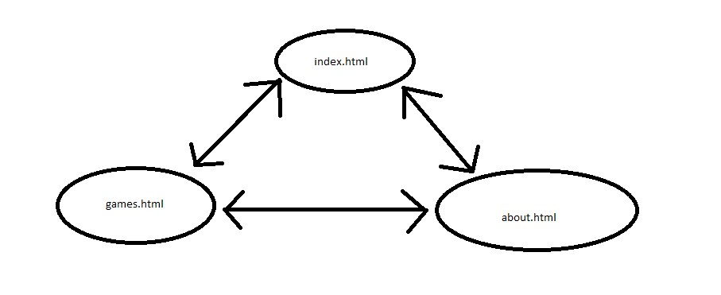

* + - * 1. **Mapa sajta**

<?xml version="1.0" encoding="UTF-8"?>

<urlset xmlns="http://www.sitemaps.org/schemas/sitemap/0.9">

<url>

<loc>index.html</loc>

<lastmod>2019-11-27</lastmod>

<changefreq>daily</changefreq>

<priority>1</priority>

</url>

<url>

<loc>about.html</loc>

<lastmod>2019-11-27</lastmod>

<changefreq>yearly</changefreq>

<priority>0.6</priority>

</url>

<url>

<loc>games.html</loc>

<lastmod>2019-11-27</lastmod>

<changefreq>weekly</changefreq>

<priority>0.9</priority>

</url>

</urlset>

* + - * 1. **Opis stranica sajta**

**index.html**

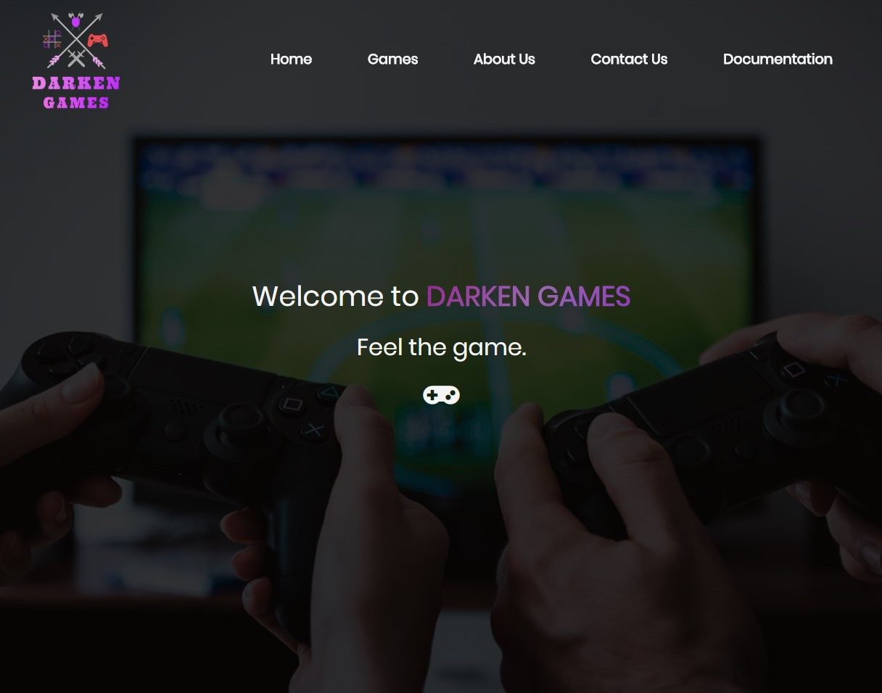

Po učitavanju stranice se dinamički ispisuje navigaciju u zaglavlju, futeru i u side navigaciji. Ima 4 background slika koje se nasumicno menjaju svaki put kada se osvezi stranica. Isto vazi i za h2 tag.

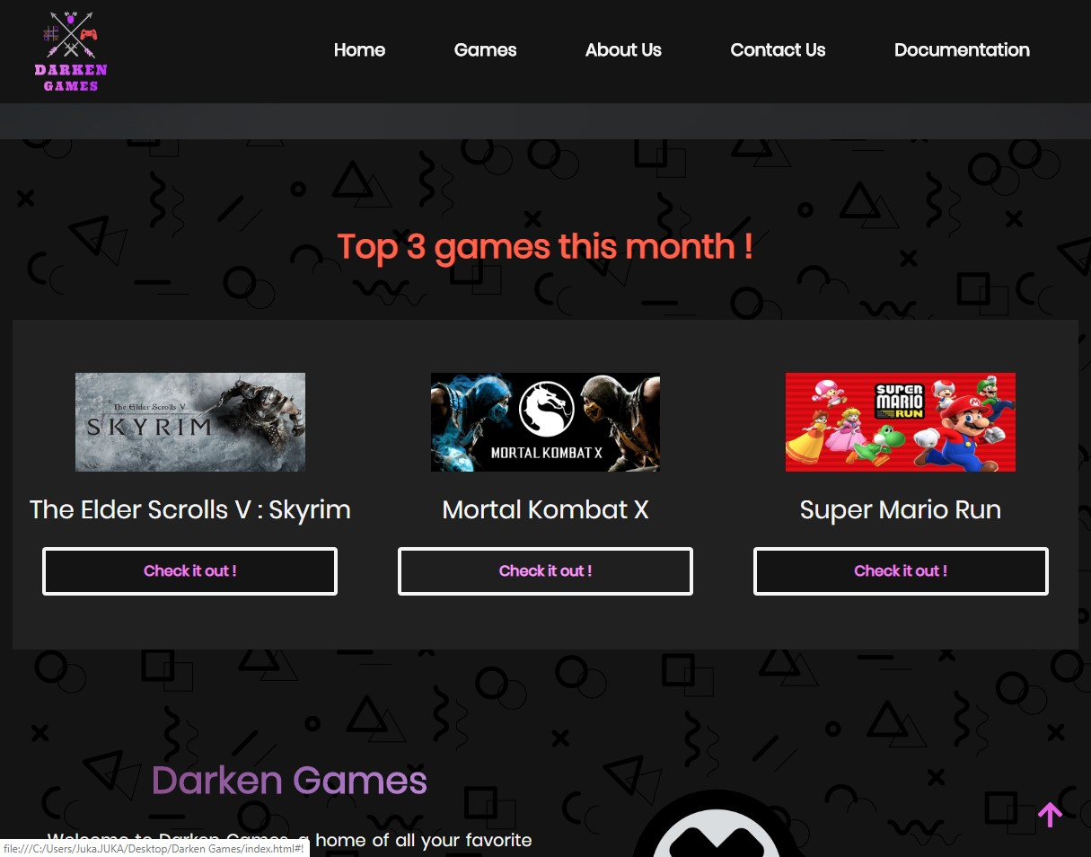

Ispisuju se 3 dinamicka bloka koja vuku podatke iz niza.

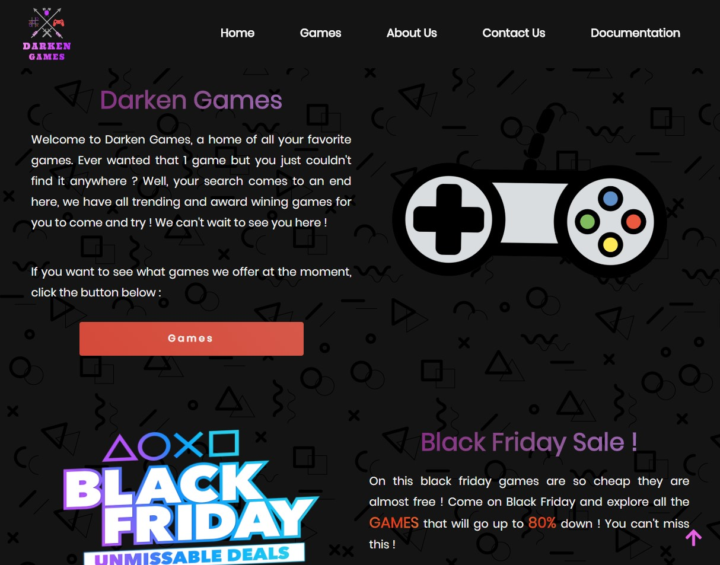

Ovo je obican html sem sto se slika dzojstika rotira za 45 stepeni na dole 2 sekunde nakon sto skrolujemo vise od 1150px.



Ispod Black Friday sekcije nalazi se carousel napravljen preko jQuery Slick plugina. Ima 4 razlicita teksta koji se smenjuju na svake 2.5 sekunde, takodje rade i na klik strelice i mogu da se vuku.

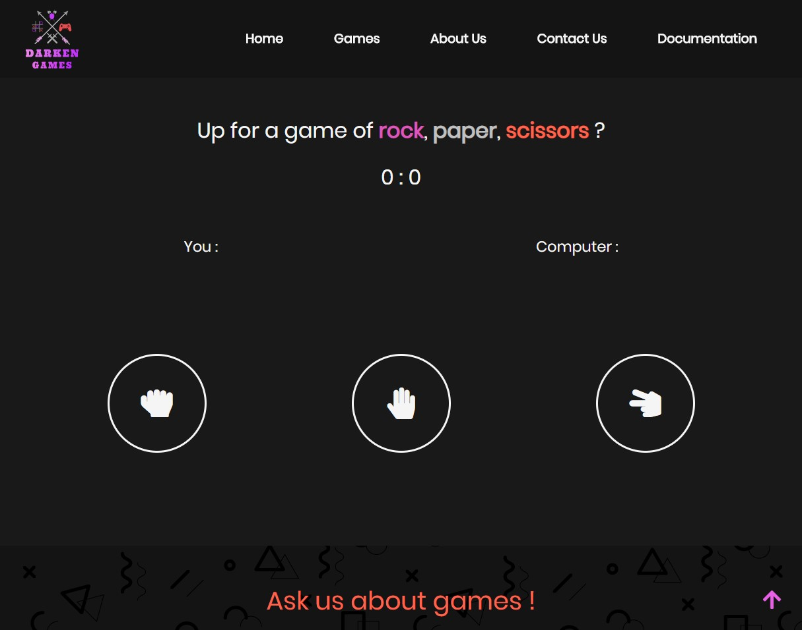

Dinamicki se ispisuju blokovi za papir, kamen, makaze. Klikom na jedan od blokova pravimo nas izbor, u isto vreme ga i racunar pravi. Kod teksta ,,You :,, se ispisuje nas izbor nakon sto kliknemo na odredjeni znak, a kod teksta ,,Computer :,, se ispisuje ispor kompjutera koji je nasumicno izabran kada se klikne na neki znak. Igra je potpuno funkcionalna, ko prvi dodje do 10 je pobednik i ispisuje ime pobednika.

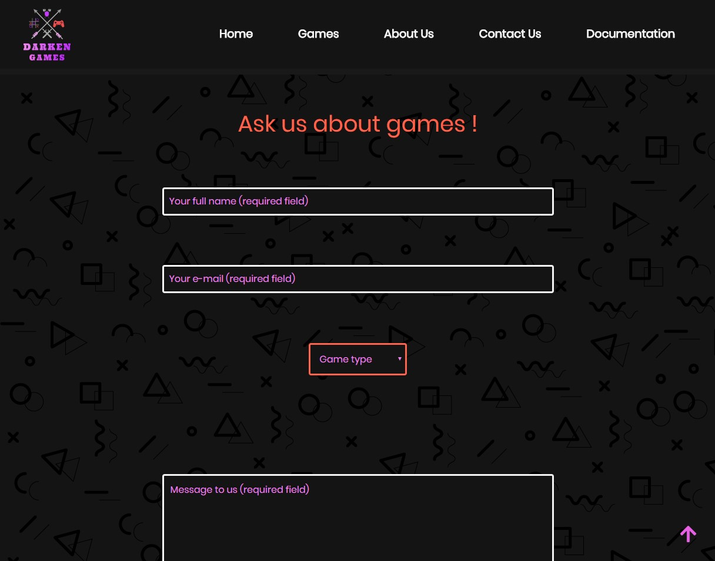

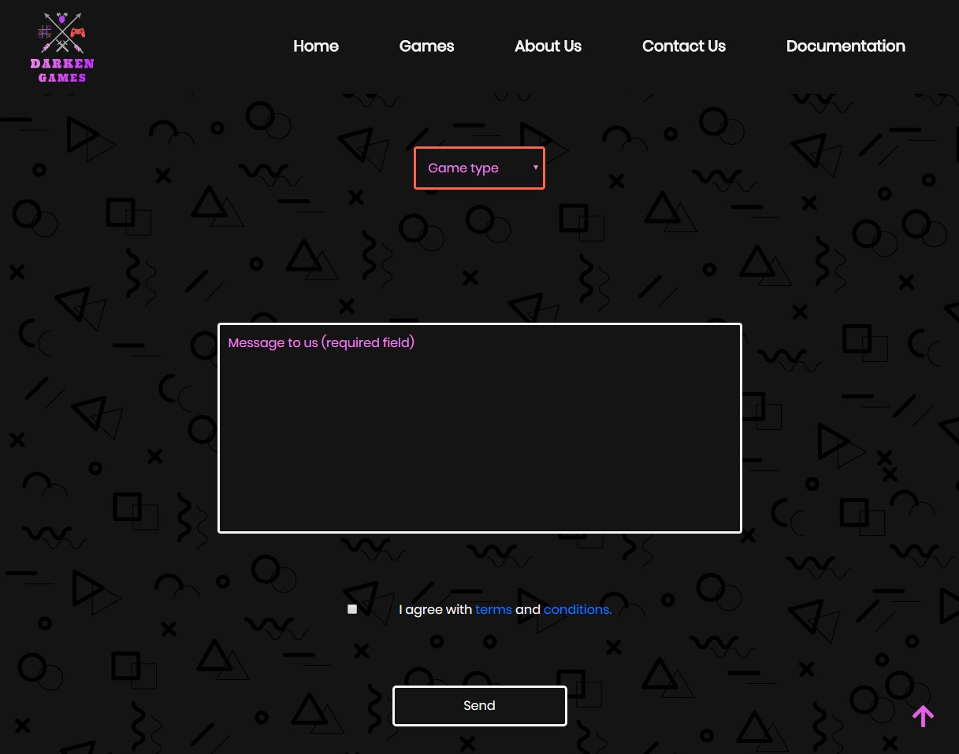

Forma ima kompletnu validaciju, kada se udje u fokus polja, a zatim izadje iz njega tj. Dogadjajem blur, sva polja koja nisu dobro popunjena dobijaju crveni border oko sebe. Klikom na taster submit ispisuju se sve greske za polja koja nisu dobro popunjena ili nisu popunjena uopste ispod istih.

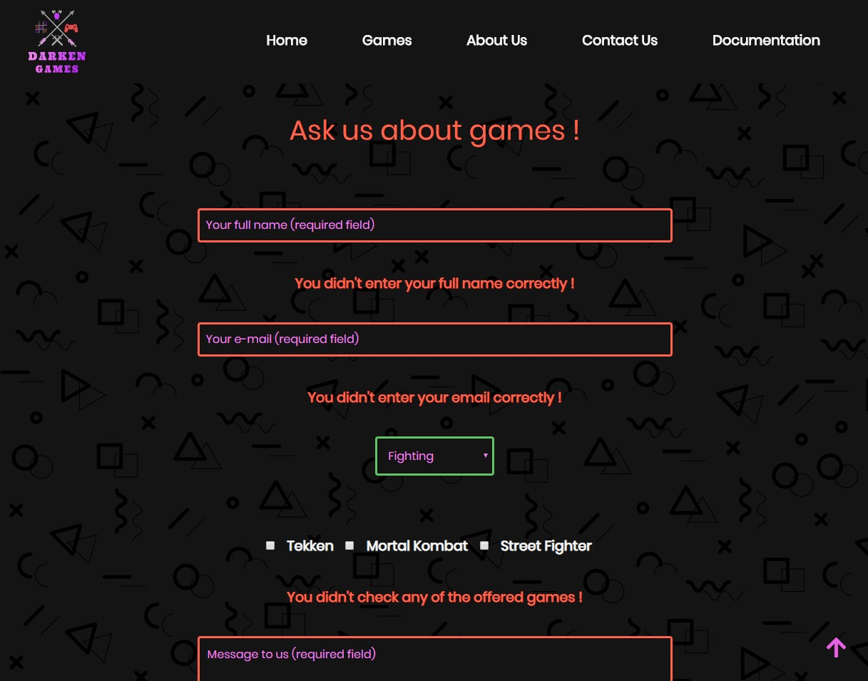

Polja koja su prosla validaciju dobijaju oko sebe zeleni border. Dogadjaj blur se dogadja na poljima za full name, email i textarea, kada izadjemo iz fokusa tih polja, njihov border postaje crven ili zelen u zavisnosti od toga da li su u skladu sa regularnim izrazom ili ne. Ukoliko jesu, border im postaje zelen i greska vezana za to polje ispod se brise ako je uopste vidljiva, u suprotnom border postaje crven i greska se ispisuje ispod polja.

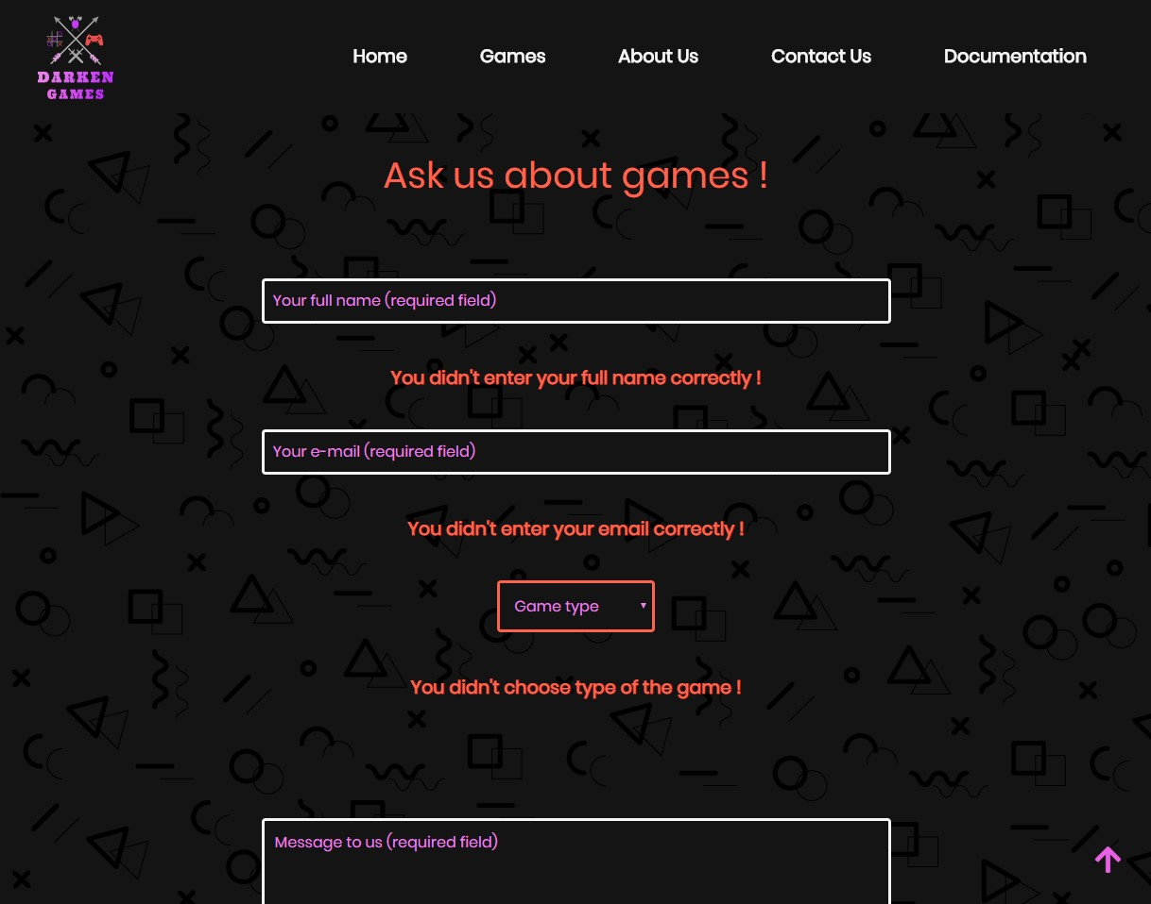

Ispisuje se greska ispod svakog polja koje nije proslo validaciju.

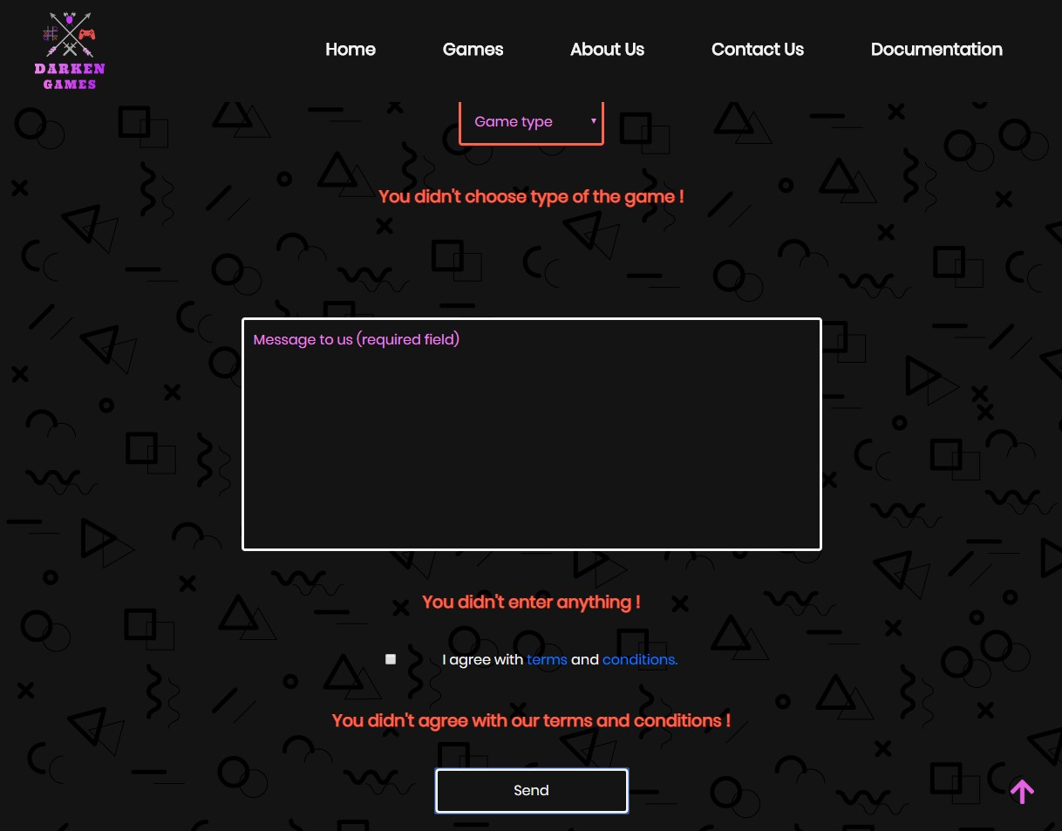

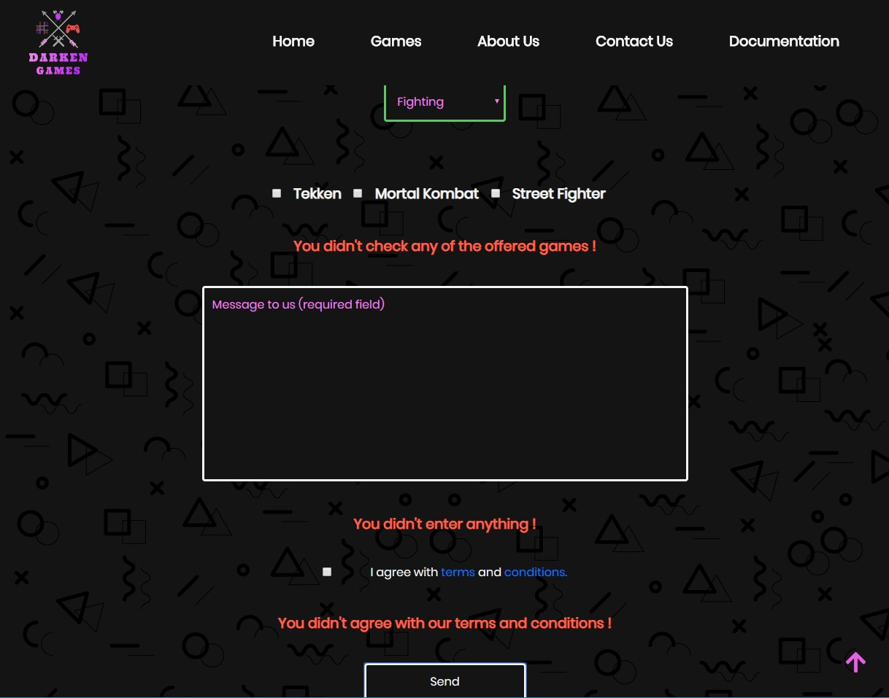

Kada se izabere Game Type, ali se ne cekira nijedna od ponudjenih igara, takodje se izbacuje dodatna greska ,,You didn't check any of the offered games !,,

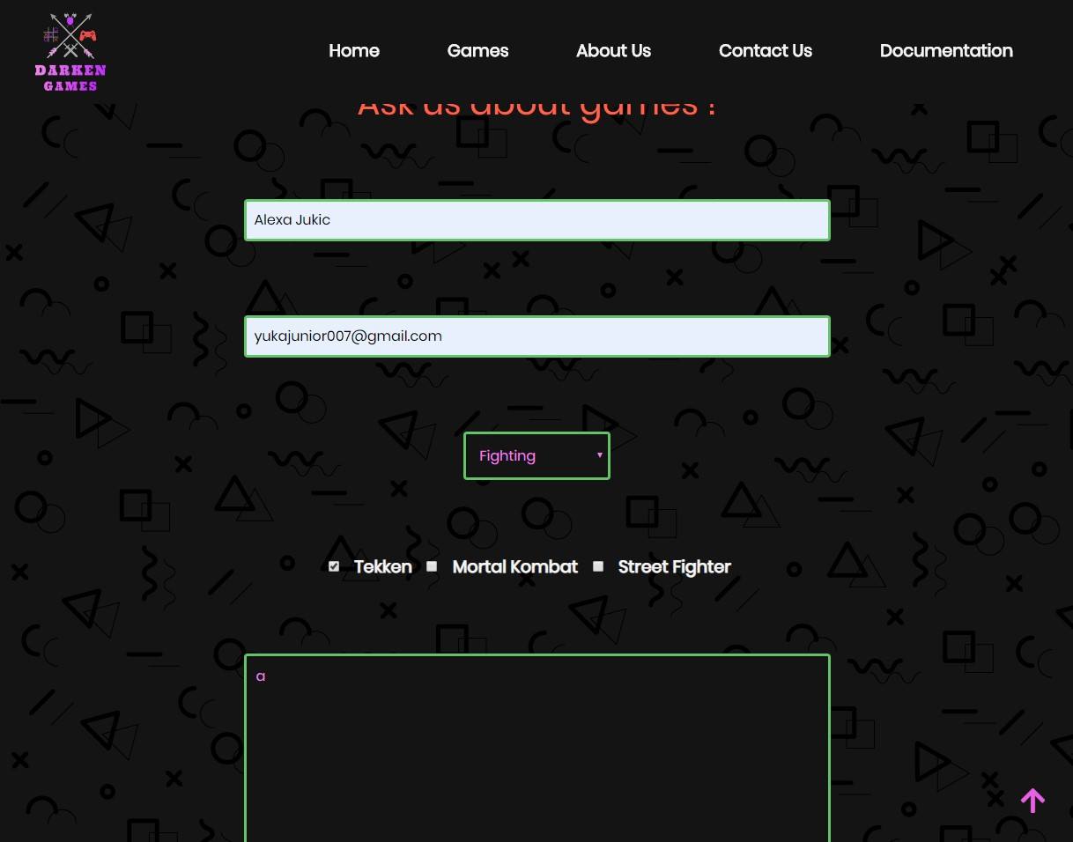

Ako je polje popunjeno i u skladu sa validacijom, oko njega se pojavljuje zeleni border.

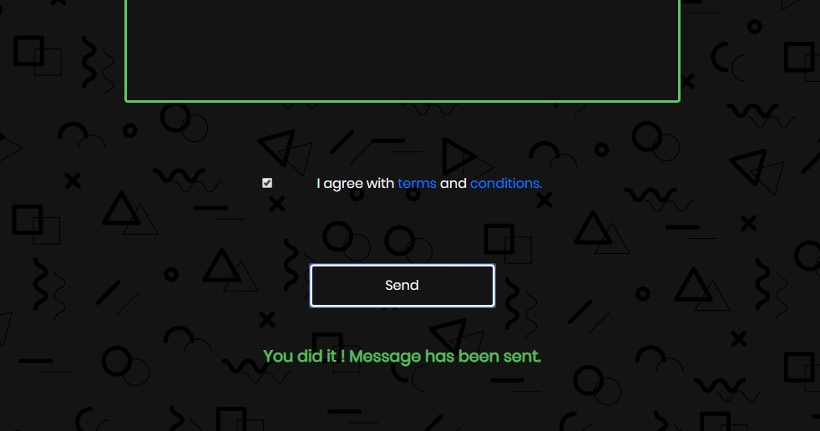

Ako su sva polja popunjena ispravno, klikom na taster Send, ispod se ispisuje poruka da smo uspesno poslali poruku.

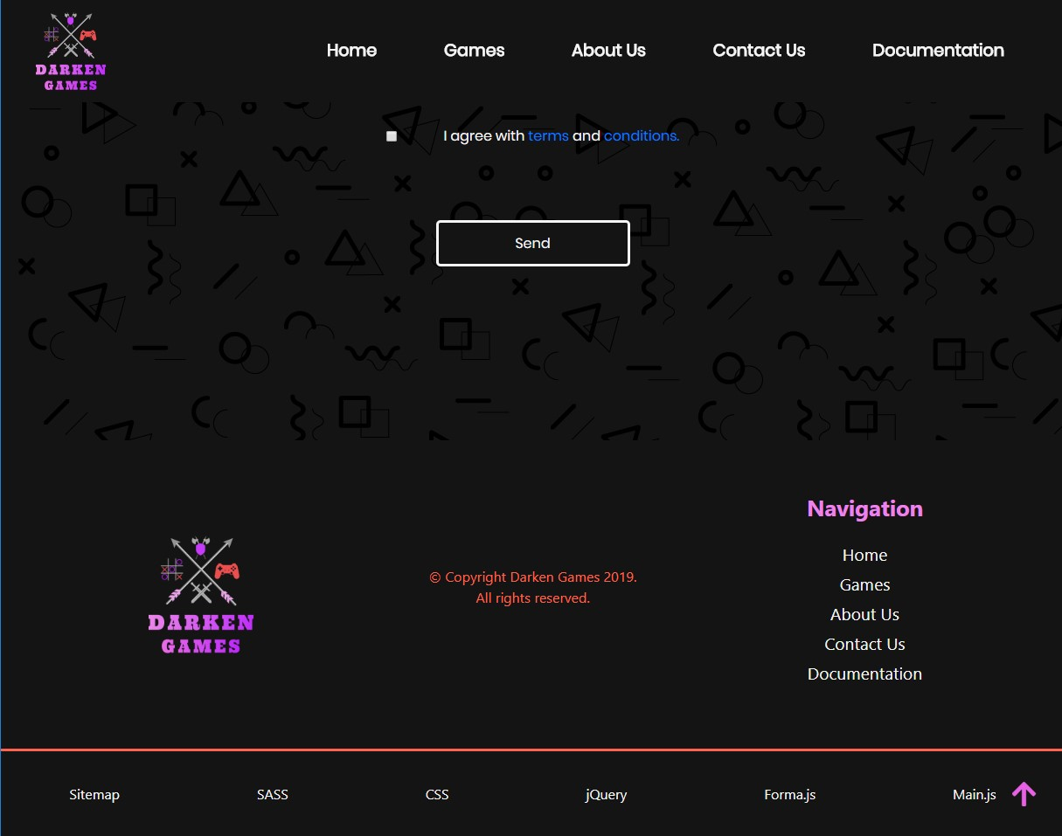

Logo i navigacija u footeru se takodje ispisju iz JavaScripta.



Nakon 9 sekundi ucitavanja stranice, pojavljuje se malo pop-up obavestenje koje se klikom na taster ,,Awesome,, zatvara i nestaje sa ekrana sve dok opet ne ucitamo stranicu i ne sacekamo 9 sekundi.

**games.html**

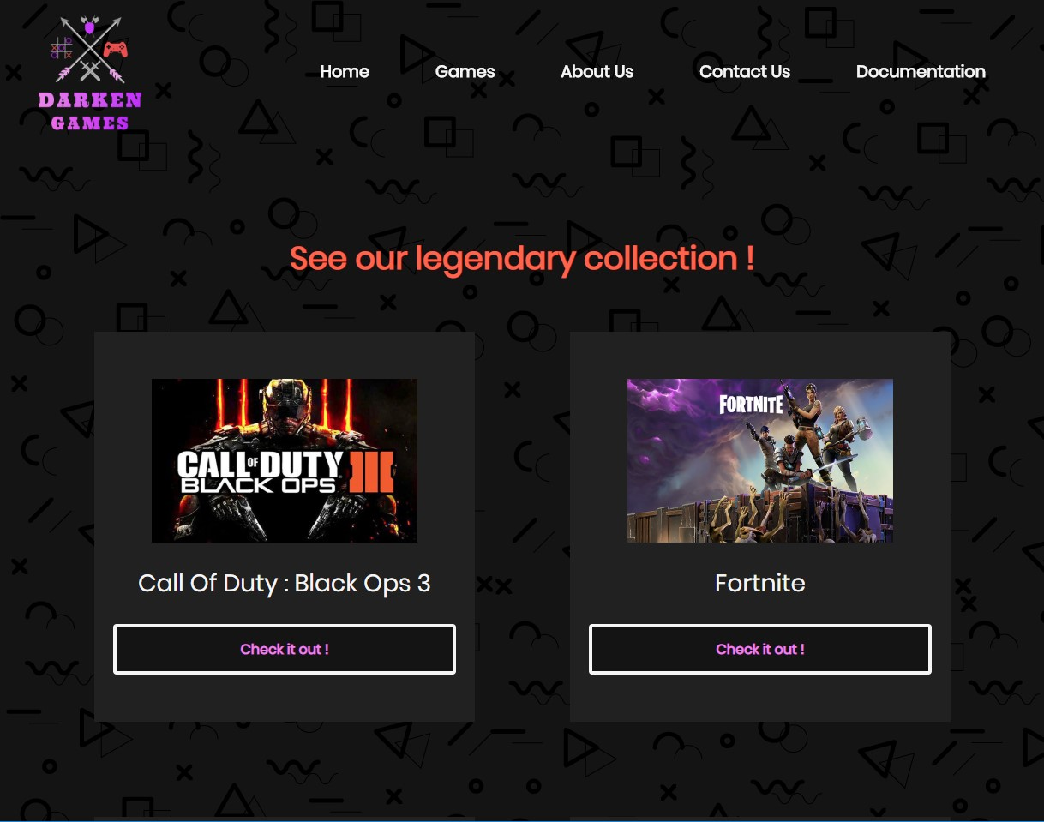

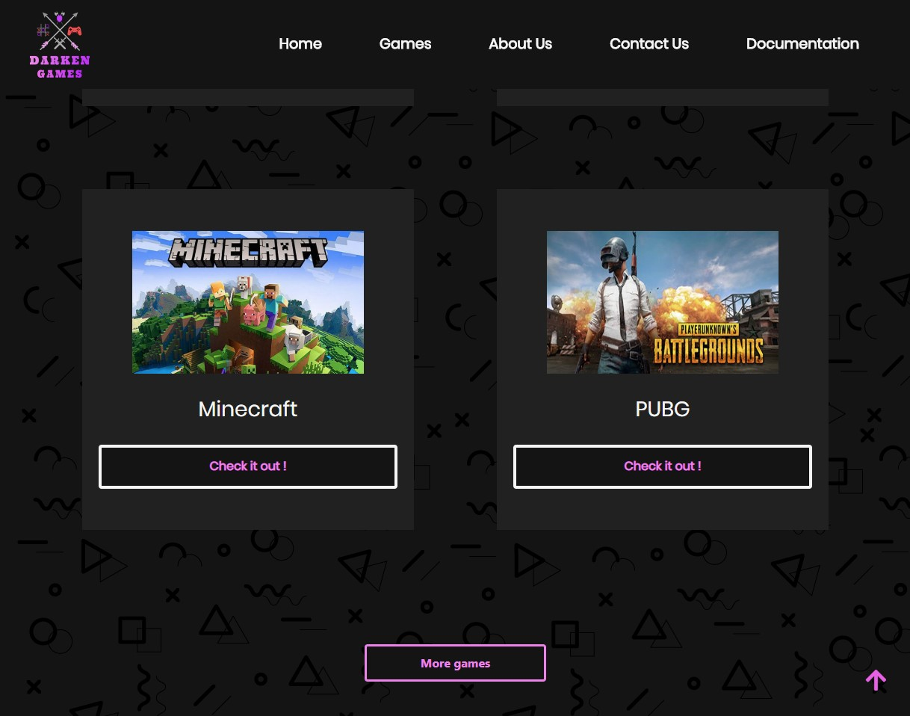

Na stranici games.html se navigacija ispisuje na isti nacin kao i na stanici index.html. Dinamicki se ispisuju prva 4 bloka i ispod njih se nalazi dugme ,,More Games,,. Klikom na ovo dugme prikazuju se jos po 2 igrice ispod zadnje 2, i tako 3 puta, nakon sto se 3 puta klikne na More Games, on nestaje sa sajta jer su to sve igre koje su u ponudi trenutno.

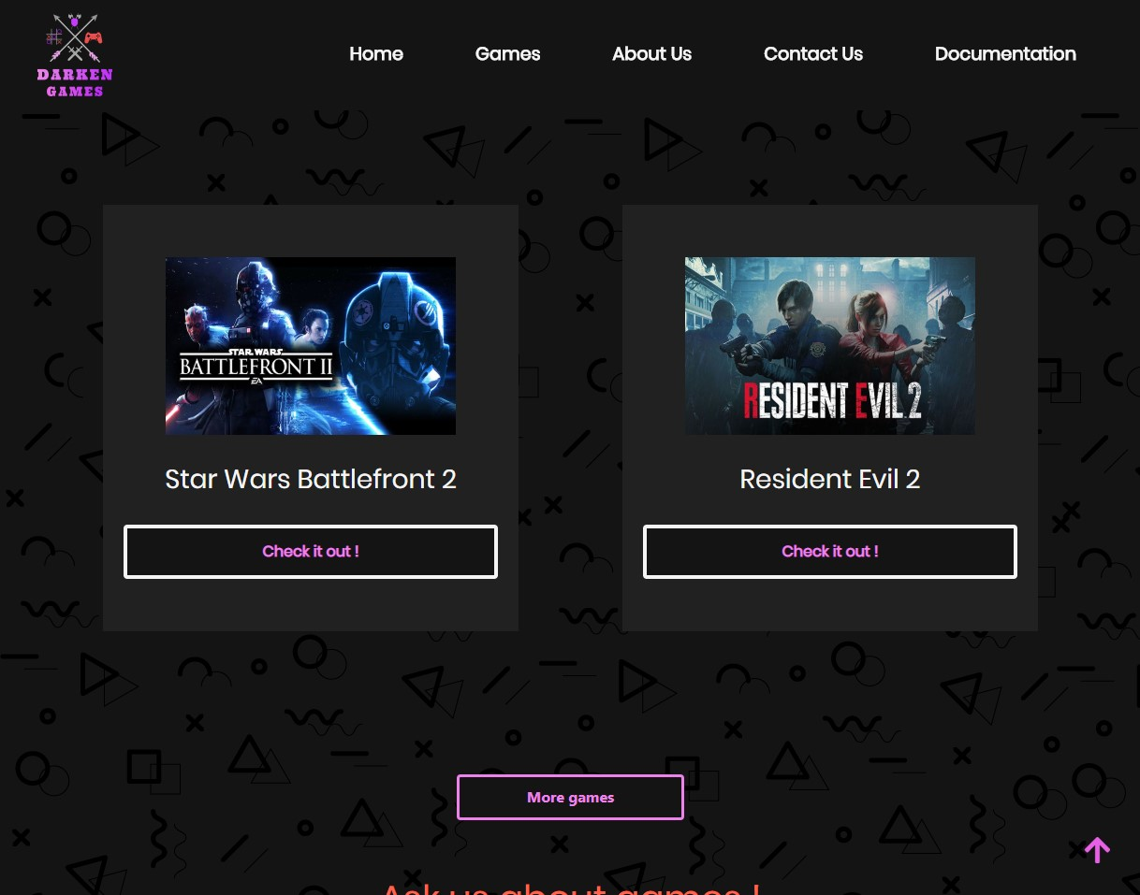

Ispis 2 igre prvim klikom na ,,More games,,.

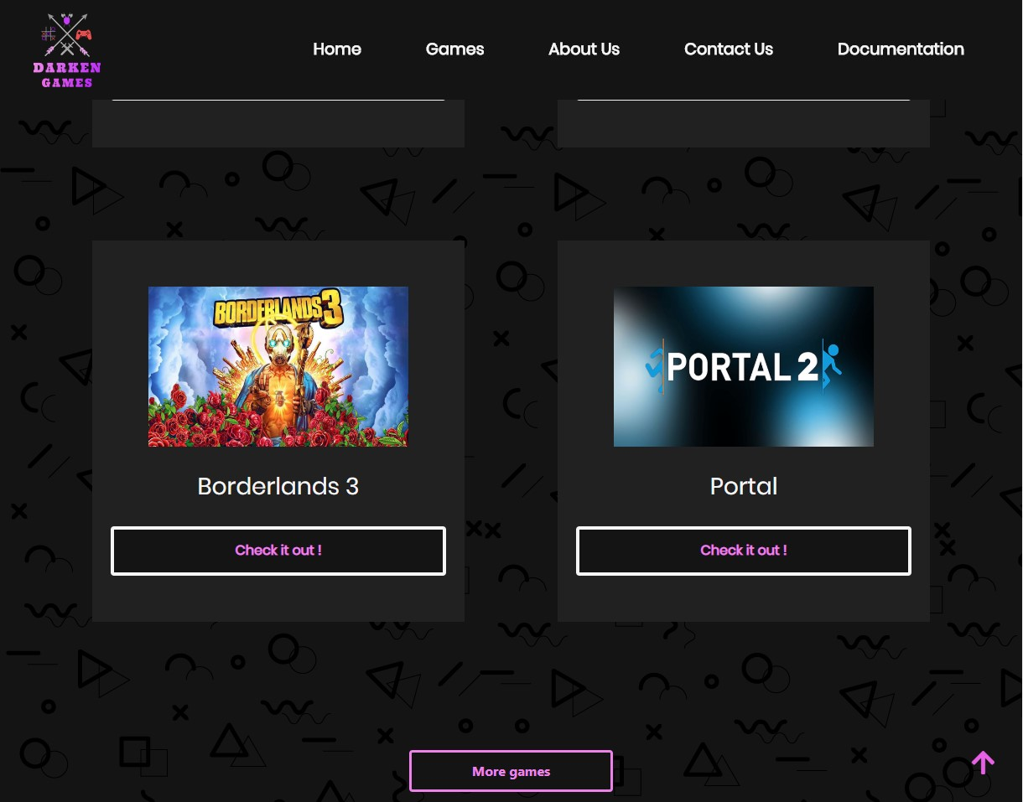

Ispis jos 2 igre drugim klikom na ,,More games,,.

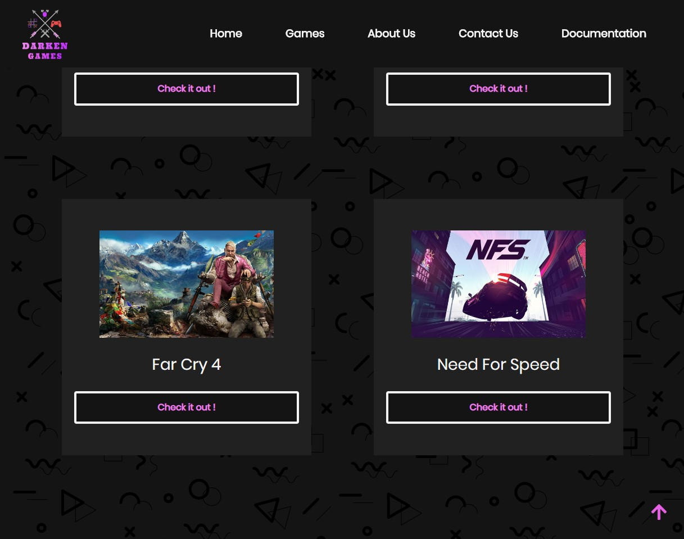

Ispis jos 2 igre trecim klikom na ,,More games,, i nestajanje tastera ,,More Games,, sa sajta.

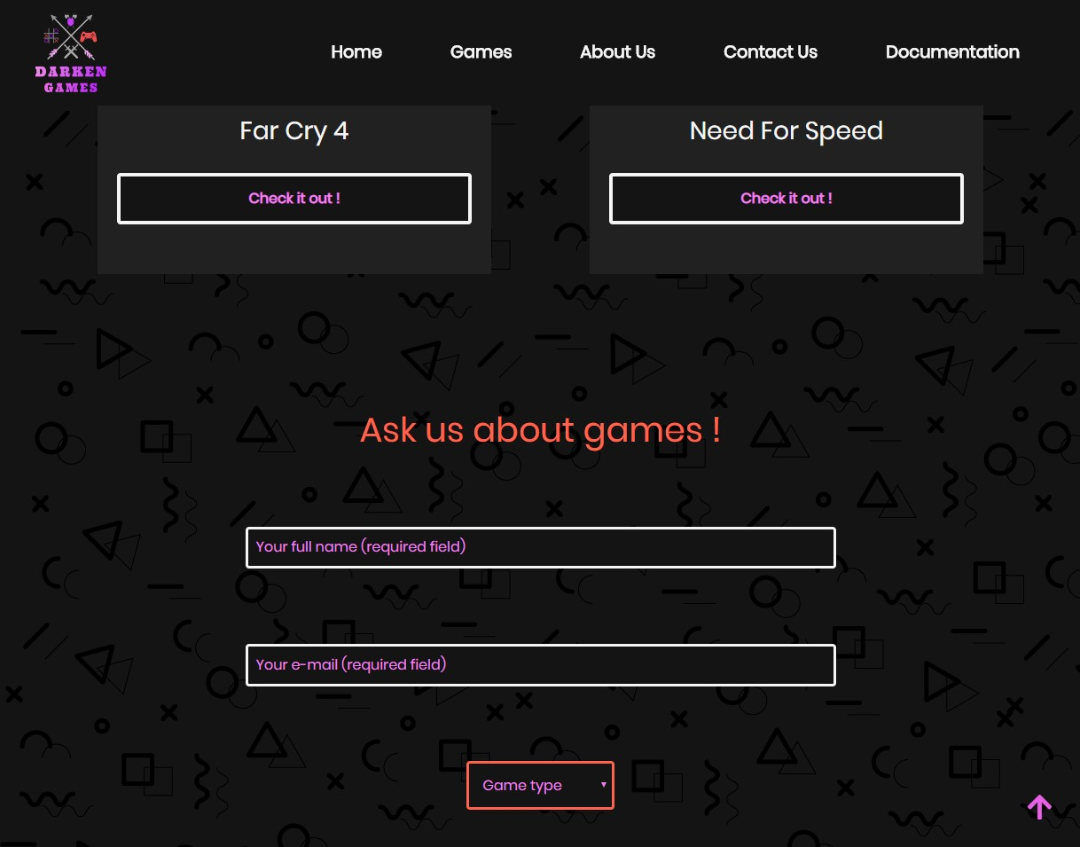

Forma se ispisuje na dnu games.html strane kao i na index.html strani

**about.html**

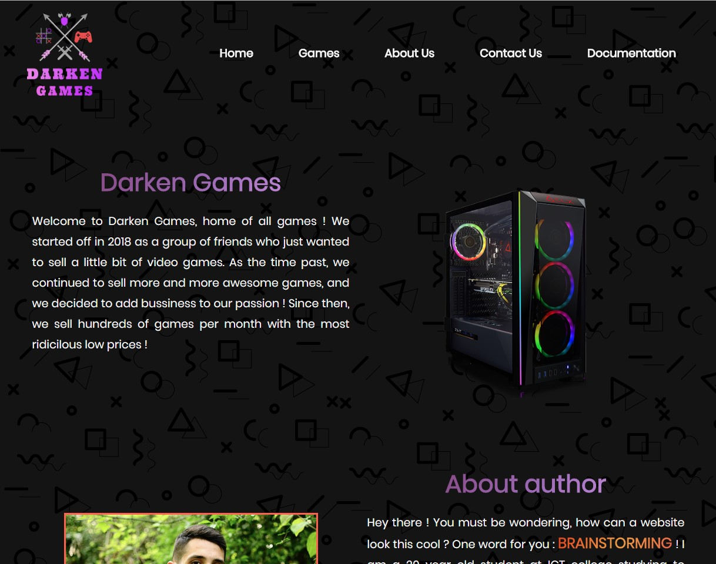

**Navigacija se dinamicki ispisuje kao i na svim drugim stranama. Obicna html sekcija o Darken Games.**

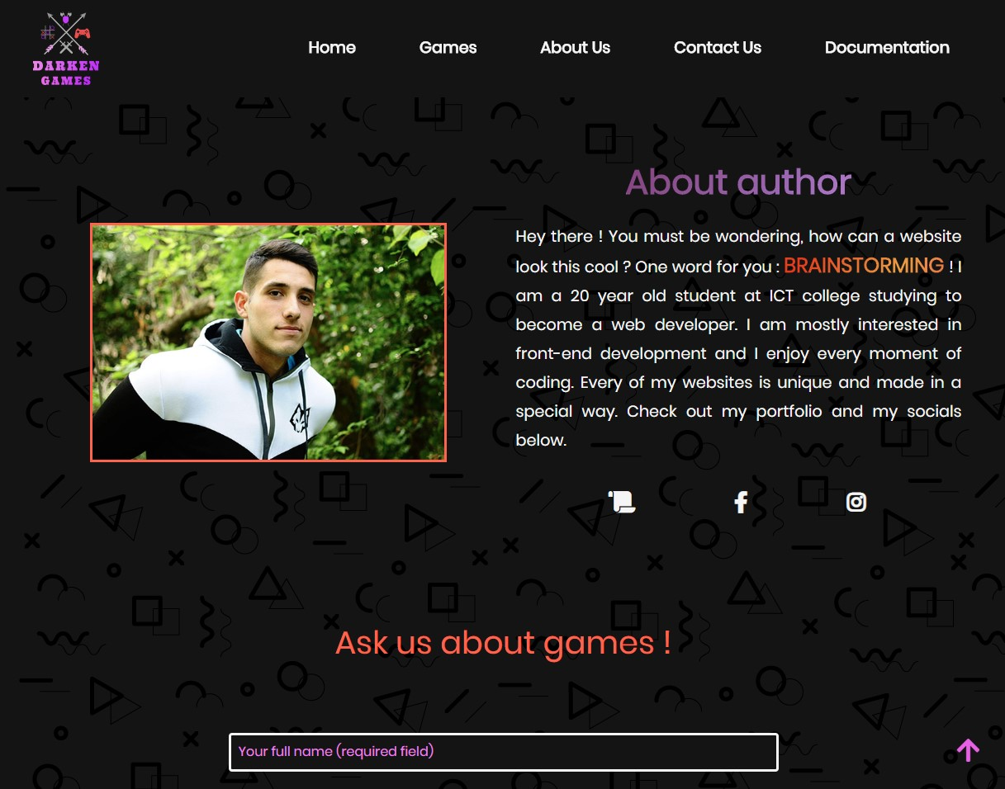

**Obicna html sekcija o autoru sa linkovima ka mom portfoliu i drustvenim mrezama.**

**NAVIGACIJA :**



**Klikom na link ,,Contact us,, sajt se spusta do sekcija sa formom koja se nalazi na istoj strani na kojoj smo trenutno.**

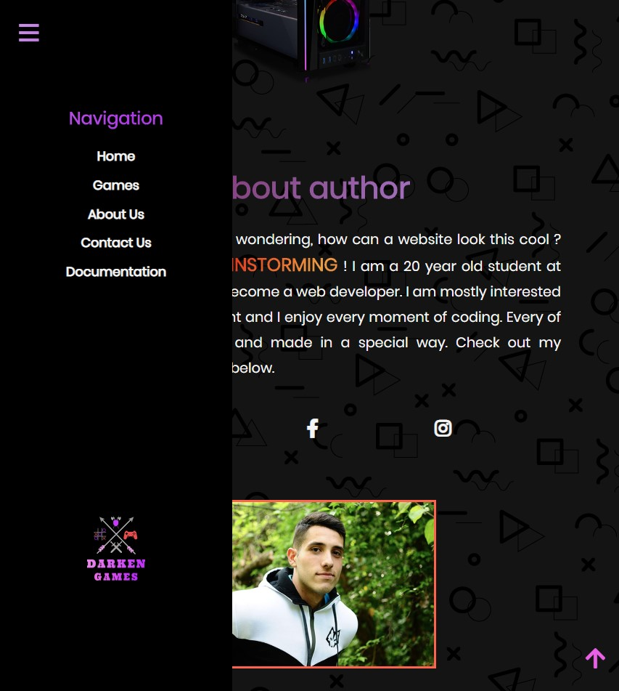

**Side navigacija se aktivira klikon na burger meni ikonicu koja se pojavljuje u gornjem levom na uredjajima ispod 992px.**

# Kodovi

# index.html

# <!DOCTYPE html>

# <html lang="en">

# <head>

# <meta charset="UTF-8">

# <meta name="viewport" content="width=device-width, initial-scale=1.0">

# <meta http-equiv="X-UA-Compatible" content="ie=edge">

# <meta name="keywords" content="Games, Darken Games, Cheap, Trending Games"/>

# <meta name="description" content="Welcome to the official website of Darken Games. Here you can find all the games we have to offer and read all the info you need. You will find the games here are so cheap they are almost as free !"/>

# <meta name="author" content="Aleksa Jukic"/>

# <link rel="icon" href="images/logo.ico"/>

# <link rel="stylesheet" href="https://stackpath.bootstrapcdn.com/bootstrap/4.3.1/css/bootstrap.min.css" integrity="sha384-ggOyR0iXCbMQv3Xipma34MD+dH/1fQ784/j6cY/iJTQUOhcWr7x9JvoRxT2MZw1T" crossorigin="anonymous">

# <link href="https://fonts.googleapis.com/css?family=Poppins&display=swap" rel="stylesheet"/>

# <link rel="stylesheet" href="https://use.fontawesome.com/releases/v5.8.2/css/all.css" integrity="sha384-oS3vJWv+0UjzBfQzYUhtDYW+Pj2yciDJxpsK1OYPAYjqT085Qq/1cq5FLXAZQ7Ay" crossorigin="anonymous"/>

# <link rel="stylesheet" href="css/slick.css"/>

# <link rel="stylesheet" type="text/css" href="css/style.min.css"/>

# <title>Darken Games | Homepage</title>

# </head>

# <body>

# <!-- Navigacija -->

# 

# <nav class="goHide">

# <div class="left">

# 

# </div>

# <div class="right" id='right1'>

# 

# 

# </div>

# </nav>

# <!-- Side navigacija -->

# <div class="sideNav">

# <div class="right" id='right2'>

# <p>Navigation</p>

# </div>

# <div class="left">

# 

# </div>

# </div>

# <!-- Triger za side navigaciju -->

# <div class="activator">

# <a href="#!"><i class="fas fa-bars"></i></a>

# </div>

# <!-- Back to top strelica -->

# <div class="arrowTop">

# <a href="#!">

# <i class="fas fa-arrow-up goTop"></i>

# </a>

# </div>

# <!-- Black Friday pop up blok -->

# <div class="popUp">

# <h3>BLACK FRIDAY SALE !</h3>

# <p>Up to <span class='redBig'>80%</span> off on majority of games !</p>

# <button class='closePop'>Awesome</button>

# </div>

# <!-- Main sekcija -->

# <section class="main">

# <div class="blackend">

# <div class="content">

# <h1 id="fillMeH1">Welcome to <span>Darken Games</span></h1>

# <h2 id="fillmeH2"></h2>

# <a href="#newGames"><i class="fas fa-gamepad"></i></a>

# </div>

# </div>

# </section>

# <!-- Top 3 games sekcija -->

# <section class='newGames container-fluid' id="newGames">

# <h2 id="newGamesFill">Top <span>3</span> games this month !</h2>

# <div class="bestGames row">

# </div>

# </section>

# <!-- Kratko o Darken Games-u -->

# <section class="described container-fluid">

# <div class="container textISlika">

# <div class="row rowDesc">

# <div class="col-lg-6 colDesc1">

# <h3>Darken Games</h3>

# <p>Welcome to Darken Games, a home of all your favorite games. Ever wanted that 1 game but you just couldn't find it anywhere ? Well, your search comes to an end here, we have all trending and award wining games for you to come and try ! We can't wait to see you here !</p>

# <p>If you want to see what games we offer at the moment, click the button below :</p>

# <a href="games.html">Games</a>

# </div>

# <div class="col-lg-6 colDesc2">

# <img src="images/controller.jpg" class="imgPlay img-fluid" alt="Controller"/>

# </div>

# </div>

# </div>

# </section>

# <!-- Black Friday Sale -->

# 

# <section class="blackFriday described container-fluid">

# <div class="container fridayContainer textISlika">

# <div class="row rowFriday rowDesc">

# <div class="col-lg-6 colFriday colDesc2">

# <img src="images/blackFriday.png" class="img-fluid blackFridayPic" alt="Black Friday Sale"/>

# </div>

# <div class="col-lg-6 colFriday1 colDesc1">

# <h3>Black Friday Sale !</h3>

# <p>On this black friday games are so cheap they are almost free ! Come on Black Friday and explore all the <span class='redBig'>games</span> that will go up to <span class='redBig'>80%</span> down ! You can't miss this !</p>

# </div>

# </div>

# </div>

# </section>

# <div class="slickCarousel">

# <div class='carEl'>Absolutely fenomenal new games every month !</div>

# <div class='carEl'>Left4Dead2 now in all of our stores !</div>

# <div class='carEl'>Mortal Kombat 11 and Far Cry 5 on sale today !</div>

# <div class='carEl'>Games ! Games ! Games !</div>

# </div>

# <!-- Iks oks sekcija -->

# <section class="iksOks container-fluid">

# <h3>Up for a game of <span>rock</span>, <span>paper</span>, <span>scissors</span> ?</h3>

# <div class="container iksOksContainer">

# <div class="row iksOksRow">

# <p id='midScore'><span id="player"></span> : <span id="ai"></span></p>

# <div class="score">

# <p id='topScore'>You : <span id='youSign'></span></p>

# 

# <p id='botScore'>Computer : <span id='aiSign'></span></p>

# </div>

# <p class='status'></p>

# </div>

# <div class="row iksOksRow1">

# <div class="signs">

# </div>

# </div>

# </div>

# </section>

# <!-- Kontakt sekcija -->

# <section class="kontakt container-fluid" id="kontakt">

# <h3>Ask us about games !</h3>

# <div class="container kontaktContainer">

# <div class="row rowKontakt">

# <div class="col-lg-12 colKontakt">

# <form action="index.html" method="POST">

# <input type="text" placeholder="Your full name (required field)" name='fullName' class='polje painted' id="punoIme"/>

# <p id='fullNameError' class='greska'></p>

# <br/>

# <input type="email" placeholder="Your e-mail (required field)" name='mail' class='polje painted' id="imeMejla"/>

# <p id='mailError' class='greska'></p>

# <br/>

# <select name="games" id="selectGames">

# <option value="0">Game type</option>

# <option value="action">Action</option>

# <option value="action">Fighting</option>

# <option value="action">Strategy</option>

# </select>

# <p id='selectError' class='greska'></p>

# <br/>

# <div class="checks">

# 

# </div>

# <p id='checkedError' class='greska'></p>

# <br/>

# <textarea name="area" id="area" placeholder="Message to us (required field)" cols="30" rows="10" class='painted'></textarea>

# <p id='areaError' class='greska'></p>

# <br/>

# <div class="sloziSe">

# <input type="checkbox" value='agree' name='agree' id='agree'/>

# <label for="agree" id='agreeLabel'>I agree with <a href="#!">terms</a> and <a href="#!">conditions.</a></label>

# </div>

# <p id='agreeError' class='greska'></p>

# <br/>

# <input type="submit" id='dugme' name='dugme' value="Send"/>

# <p id='uspeh'></p>

# </form>

# </div>

# </div>

# </div>

# </section>

# <!-- Footer -->

# <section class="footer container-fluid">

# <div class="container footerContainer">

# <div class="row rowFooter">

# <div class="col-lg-4 colFooter1">

# <div class="left">

# 

# </div>

# </div>

# <div class="col-lg-4 copy">

# <p>&copy; Copyright Darken Games 2019.<br/>All rights reserved.</p>

# </div>

# <div class="col-lg-4 colFooter2">

# <p>Navigation</p>

# <div class="right" id='right3'>

# 

# </div>

# </div>

# </div>

# </div>

# <div class="col-lg-12 usefulLinks">

# 

# <a href="sitemap.xml" target="_blank">Sitemap</a>

# <a href="css/style.scss" target="_blank">SASS</a>

# <a href="css/style.css" target="_blank">CSS</a>

# <a href="js/animacijeIndex.js" target="_blank">jQuery</a>

# <a href="js/formCheck.js" target="_blank">Forma.js</a>

# <a href="js/mainIndex.js" target="_blank">Main.js</a>

# </div>

# </section>

# <script src="https://code.jquery.com/jquery-3.4.1.js"></script>

# <script src="https://cdnjs.cloudflare.com/ajax/libs/popper.js/1.14.7/umd/popper.min.js"></script>

# <script src="https://stackpath.bootstrapcdn.com/bootstrap/4.3.1/js/bootstrap.min.js"></script>

# <!-- Moji js failovi -->

# <script src="js/mainIndex.min.js" type="text/javascript"></script>

# <script src="js/animacijeIndex.min.js"></script>

# <script src='js/formCheck.min.js' type='text/javascript'></script>

# <script src='js/slick.min.js'></script>

# </body>

# </html>

# games.html

# <!DOCTYPE html>

# <html lang="en">

# <head>

# <meta charset="UTF-8">

# <meta name="viewport" content="width=device-width, initial-scale=1.0">

# <meta http-equiv="X-UA-Compatible" content="ie=edge">

# <meta name="keywords" content="Games, Darken Games, Cheap, Trending Games"/>

# <meta name="description" content="Welcome to games page of Darken Games. See all the games we offer and enjoy the view !"/>

# <meta name="author" content="Aleksa Jukic"/>

# <link rel="icon" href="images/logo.ico"/>

# <link rel="stylesheet" href="https://stackpath.bootstrapcdn.com/bootstrap/4.3.1/css/bootstrap.min.css" integrity="sha384-ggOyR0iXCbMQv3Xipma34MD+dH/1fQ784/j6cY/iJTQUOhcWr7x9JvoRxT2MZw1T" crossorigin="anonymous">

# <link href="https://fonts.googleapis.com/css?family=Poppins&display=swap" rel="stylesheet"/>

# <link rel="stylesheet" href="https://use.fontawesome.com/releases/v5.8.2/css/all.css" integrity="sha384-oS3vJWv+0UjzBfQzYUhtDYW+Pj2yciDJxpsK1OYPAYjqT085Qq/1cq5FLXAZQ7Ay" crossorigin="anonymous"/>

# <link rel="stylesheet" type="text/css" href="css/style.min.css"/>

# <title>Darken Games | Games</title>

# </head>

# <body>

# <!-- Navigacija -->

# 

# <nav class="goHide">

# <div class="left">

# 

# </div>

# <div class="right">

# 

# </div>

# </nav>

# <!-- Side navigacija -->

# <div class="sideNav">

# <div class="right">

# <p>Navigation</p>

# </div>

# <div class="left">

# 

# </div>

# </div>

# <!-- Triger za side navigaciju -->

# <div class="activator">

# <a href="#!"><i class="fas fa-bars"></i></a>

# </div>

# <!-- Back to top strelica -->

# <div class="arrowTop">

# <a href="#!">

# <i class="fas fa-arrow-up goTop"></i>

# </a>

# </div>

# <!-- Glavni deo za ispis blokova -->

# <section class='newGames gamesSeperate container-fluid' id="newGames">

# <h1 id="newGamesFill">See our legendary collection !</h1>

# 

# <div class="gamesSpecial container">

# </div>

# 

# </section>

# <a href="#!" class="loadMore">More games</a>

# <!-- Kontakt sekcija -->

# <section class="kontakt container-fluid" id="kontakt">

# <h3>Ask us about games !</h3>

# <div class="container kontaktContainer">

# <div class="row rowKontakt">

# <div class="col-lg-12 colKontakt">

# <form action="index.html" method="POST">

# <input type="text" placeholder="Your full name (required field)" name='fullName' class='polje painted' id="punoIme"/>

# <p id='fullNameError' class='greska'></p>

# <br/>

# <input type="email" placeholder="Your e-mail (required field)" name='mail' class='polje painted' id="imeMejla"/>

# <p id='mailError' class='greska'></p>

# <br/>

# <select name="games" id="selectGames">

# <option value="0">Game type</option>

# <option value="action">Action</option>

# <option value="action">Fighting</option>

# <option value="action">Strategy</option>

# </select>

# <p id='selectError' class='greska'></p>

# <br/>

# <div class="checks">

# 

# </div>

# <p id='checkedError' class='greska'></p>

# <br/>

# <textarea name="area" id="area" placeholder="Message to us (required field)" cols="30" rows="10" class='painted'></textarea>

# <p id='areaError' class='greska'></p>

# <br/>

# <div class="sloziSe">

# <input type="checkbox" value='agree' name='agree' id='agree'/>

# <label for="agree" id='agreeLabel'>I agree with <a href="#!">terms</a> and <a href="#!">conditions.</a></label>

# </div>

# <p id='agreeError' class='greska'></p>

# <br/>

# <input type="submit" id='dugme' name='dugme' value="Send"/>

# <p id='uspeh'></p>

# </form>

# </div>

# </div>

# </div>

# </section>

# <!-- Footer -->

# <section class="footer container-fluid">

# <div class="container footerContainer">

# <div class="row rowFooter">

# <div class="col-lg-4 colFooter1">

# <div class="left">

# 

# </div>

# </div>

# <div class="col-lg-4 copy">

# <p>&copy; Copyright Darken Games 2019.<br/>All rights reserved.</p>

# </div>

# <div class="col-lg-4 colFooter2">

# <p>Navigation</p>

# <div class="right">

# 

# </div>

# </div>

# </div>

# </div>

# <div class="col-lg-12 usefulLinks">

# 

# <a href="sitemap.xml" target="_blank">Sitemap</a>

# <a href="css/style.scss" target="_blank">SASS</a>

# <a href="css/style.css" target="_blank">CSS</a>

# <a href="js/animacijeIndex.js" target="_blank">jQuery</a>

# <a href="js/formCheck.js" target="_blank">Forma.js</a>

# <a href="js/mainGames.js" target="_blank">Main.js</a>

# </div>

# </section>

# <script src="https://code.jquery.com/jquery-3.4.1.js"></script>

# <script src="https://cdnjs.cloudflare.com/ajax/libs/popper.js/1.14.7/umd/popper.min.js"></script>

# <script src="https://stackpath.bootstrapcdn.com/bootstrap/4.3.1/js/bootstrap.min.js"></script>

# <!-- Moji js failovi -->

# <script src="js/mainGames.min.js" type="text/javascript"></script>

# <script src="js/animacijeIndex.min.js"></script>

# <script src='js/formCheck.min.js' type='text/javascript'></script>

# </body>

# </html>

# about.html

# <!DOCTYPE html>

# <html lang="en">

# <head>

# <meta charset="UTF-8">

# <meta name="viewport" content="width=device-width, initial-scale=1.0">

# <meta http-equiv="X-UA-Compatible" content="ie=edge">

# <link rel="icon" href="images/logo.ico"/>

# <link rel="stylesheet" href="https://stackpath.bootstrapcdn.com/bootstrap/4.3.1/css/bootstrap.min.css" integrity="sha384-ggOyR0iXCbMQv3Xipma34MD+dH/1fQ784/j6cY/iJTQUOhcWr7x9JvoRxT2MZw1T" crossorigin="anonymous">

# <link href="https://fonts.googleapis.com/css?family=Poppins&display=swap" rel="stylesheet"/>

# <link rel="stylesheet" href="https://use.fontawesome.com/releases/v5.8.2/css/all.css" integrity="sha384-oS3vJWv+0UjzBfQzYUhtDYW+Pj2yciDJxpsK1OYPAYjqT085Qq/1cq5FLXAZQ7Ay" crossorigin="anonymous"/>

# <link rel="stylesheet" type="text/css" href="css/style.min.css"/>

# <title>Darken Games | About</title>

# </head>

# <body>

# <!-- Navigacija -->

# 

# <nav class="goHide">

# <div class="left">

# 

# </div>

# <div class="right">

# 

# </div>

# </nav>

# <!-- Side navigacija -->

# <div class="sideNav">

# <div class="right">

# <p>Navigation</p>

# </div>

# <div class="left">

# 

# </div>

# </div>

# <!-- Triger za side navigaciju -->

# <div class="activator">

# <a href="#!"><i class="fas fa-bars"></i></a>

# </div>

# <!-- Back to top strelica -->

# <div class="arrowTop">

# <a href="#!">

# <i class="fas fa-arrow-up goTop"></i>

# </a>

# </div>

# <!-- Glavni deo za ispis blokova -->

# <section class="described container-fluid descAbout">

# <div class="container textISlika">

# <div class="row rowDesc">

# 

# <div class="col-lg-6 colDesc1">

# 

# <h1>Darken Games</h1>

# <p id="smanjiAbout0">Welcome to Darken Games, home of all games ! We started off in 2018 as a group of friends who just wanted to sell a little bit of video games. As the time past, we continued to sell more and more awesome games, and we decided to add bussiness to our passion ! Since then, we sell hundreds of games per month with the most ridicilous low prices !</p>

# 

# </div>

# 

# <div class="col-lg-6 colDesc2">

# <img src="images/gamingPc.png" class="img-fluid" alt="Controller"/>

# </div>

# 

# </div>

# </div>

# 

# </section>

# <section class="blackFriday described container-fluid">

# <div class="container fridayContainer textISlika">

# 

# <div class="row rowFriday rowDesc">

# 

# <div class="col-lg-6 colFriday colDesc2">

# <img src="images/me.jpg" class="img-fluid blackFridayPic borderPicAbout" alt="Black Friday Sale"/>

# </div>

# 

# <div class="col-lg-6 colFriday1 colDesc1">

# 

# <h2>About author</h2>

# <p id="smanjiAbout">Hey there ! You must be wondering, how can a website look this cool ? One word for you : <span class='redBig'>brainstorming</span> ! I am a 20 year old student at ICT college studying to become a web developer. I am mostly interested in front-end development and I enjoy every moment of coding. Every of my websites is unique and made in a special way. Check out my portfolio and my socials below.</p>

# <div class="mojeStvari">

# <a href="#!" class="stvari">

# <i class="fas fa-scroll vodiMe"></i>

# </a>

# <a href="#!" class="stvari">

# <i class="fab fa-facebook-f vodiMe"></i>

# </a>

# <a href="#!" class="stvari">

# <i class="fab fa-instagram vodiMe"></i>

# </a>

# </div>

# 

# </div>

# 

# </div>

# 

# </div>

# 

# </section>

# <!-- Kontakt sekcija -->

# <section class="kontakt container-fluid" id="kontakt">

# <h3>Ask us about games !</h3>

# <div class="container kontaktContainer">

# <div class="row rowKontakt">

# <div class="col-lg-12 colKontakt">

# <form action="index.html" method="POST">

# <input type="text" placeholder="Your full name (required field)" name='fullName' class='polje painted' id="punoIme"/>

# <p id='fullNameError' class='greska'></p>

# <br/>

# <input type="email" placeholder="Your e-mail (required field)" name='mail' class='polje painted' id="imeMejla"/>

# <p id='mailError' class='greska'></p>

# <br/>

# <select name="games" id="selectGames">

# <option value="0">Game type</option>

# <option value="action">Action</option>

# <option value="action">Fighting</option>

# <option value="action">Strategy</option>

# </select>

# <p id='selectError' class='greska'></p>

# <br/>

# <div class="checks">

# 

# </div>

# <p id='checkedError' class='greska'></p>

# <br/>

# <textarea name="area" id="area" placeholder="Message to us (required field)" cols="30" rows="10" class='painted'></textarea>

# <p id='areaError' class='greska'></p>

# <br/>

# <div class="sloziSe">

# <input type="checkbox" value='agree' name='agree' id='agree'/>

# <label for="agree" id='agreeLabel'>I agree with <a href="#!">terms</a> and <a href="#!">conditions.</a></label>

# </div>

# <p id='agreeError' class='greska'></p>

# <br/>

# <input type="submit" id='dugme' name='dugme' value="Send"/>

# <p id='uspeh'></p>

# </form>

# </div>

# </div>

# </div>

# </section>

# <!-- Footer -->

# <section class="footer container-fluid">

# <div class="container footerContainer">

# <div class="row rowFooter">

# <div class="col-lg-4 colFooter1">

# <div class="left">

# 

# </div>

# </div>

# <div class="col-lg-4 copy">

# <p>&copy; Copyright Darken Games 2019.<br/>All rights reserved.</p>

# </div>

# <div class="col-lg-4 colFooter2">

# <p>Navigation</p>

# <div class="right">

# 

# </div>

# </div>

# </div>

# </div>

# <div class="col-lg-12 usefulLinks">

# 

# <a href="sitemap.xml" target="_blank">Sitemap</a>

# <a href="css/style.scss" target="_blank">SASS</a>

# <a href="css/style.css" target="_blank">CSS</a>

# <a href="js/animacijeIndex.js" target="_blank">jQuery</a>

# <a href="js/formCheck.js" target="_blank">Forma.js</a>

# <a href="js/mainGames.js" target="_blank">Main.js</a>

# </div>

# </section>

# <script src="https://code.jquery.com/jquery-3.4.1.js"></script>

# <script src="https://cdnjs.cloudflare.com/ajax/libs/popper.js/1.14.7/umd/popper.min.js"></script>

# <script src="https://stackpath.bootstrapcdn.com/bootstrap/4.3.1/js/bootstrap.min.js"></script>

# <!-- Moji js failovi -->

# <script src="js/mainGames.min.js" type="text/javascript"></script>

# <script src="js/animacijeIndex.min.js"></script>

# <script src='js/formCheck.min.js' type='text/javascript'></script>

# </body>

# </html>

# CSS

# style.scss

# * {

# margin: 0px;

# padding: 0px;

# }

# $f : flex;

# $sa : space-around;

# $sb : space-between;

# $fw : wrap;

# $c : center;

# $co : column;

# $font : 'Poppins', sans-serif;

# $d0: 1390px;

# $d1: 1120px;

# $d2: 992px;

# $d3: 768px;

# $d4: 576px;

# $d5: 480px;

# $d6: 386px;

# @mixin d0 {

# @media (max-width: #{$d0}){

# @content;

# }

# }

# @mixin d1 {

# @media (max-width: #{$d1}){

# @content;

# }

# }

# @mixin d2 {

# @media (max-width: #{$d2}){

# @content;

# }

# }

# @mixin d3 {

# @media (max-width: #{$d3}){

# @content;

# }

# }

# @mixin d4 {

# @media (max-width: #{$d4}){

# @content;

# }

# }

# @mixin d5 {

# @media (max-width: #{$d5}){

# @content;

# }

# }

# @mixin d6 {

# @media (max-width: #{$d6}){

# @content;

# }

# }

# html{

# max-width: 100%;

# scroll-behavior: smooth;

# }

# body {

# 

# max-width: 100%;

# background: #141414;

# background-image: url('../images/bodyBackground.png');

# // Pravljenje glave navigacije

# .goHide {

# width: 100%;

# background: transparent;

# position: fixed;

# top: 0px;

# display: $f;

# justify-content: $sa;

# align-items: $c;

# transition: .9s;

# z-index: 999;

# @include d2{

# display: none;

# }

# .left {

# width: 20%;

# a {

# .logo {

# width: 150px;

# margin: 4% 0%;

# transition: .9s;

# }

# }

# }

# .right {

# width: 70%;

# ul {

# list-style-type: none;

# display: $f;

# justify-content: $sa;

# align-items: $c;

# margin-bottom: 0px;

# li{

# a {

# font-family: $font;

# text-decoration: none;

# color: whitesmoke;

# font-size: 1.2em;

# font-weight: bold;

# transition: .6s;

# 

# &:hover {

# color: tomato;

# }

# }

# }

# }

# 

# }

# }

# .nav1 {

# background: #141414;

# }

# /*

# -webkit-background-clip: text;

# -webkit-text-fill-color: transparent;

# */

# // Pravljenje side navigacije

# .sideNav {

# width: 320px;

# position: fixed;

# background: #000;

# top: 0px;

# bottom: 0px;

# display: $f;

# flex-direction: $co;

# justify-content: $sa;

# align-items: $c;

# font-family: $font;

# z-index: 999;

# p {

# text-align: $c;

# font-weight: bold;

# background: linear-gradient(303deg, #bc71e1, #ad38e7, #c98de7, #ac87be);

# background-size: 800% 800%;

# animation: purpleLinear 4s ease infinite;

# -webkit-background-clip: text;

# -webkit-text-fill-color: transparent;

# font-size: 1.5em;

# 

# }

# ul {

# list-style-type: none;

# text-align: $c;

# margin-top: 15%;

# li {

# margin: 10% 0%;

# a {

# font-family: $font;

# text-decoration: none;

# color: whitesmoke;

# font-size: 1.1em;

# font-weight: bold;

# transition: .6s;

# 

# &:hover {

# color: tomato;

# }

# }

# }

# }

# }

# .activator {

# position: fixed;

# top: 3.5%;

# left: 3%;

# z-index: 999;

# display: none;

# @include d2{

# display: block;

# }

# a{

# i {

# font-size: 2em;

# background: linear-gradient(303deg, #bc71e1, #ad38e7, #c98de7, #ac87be);

# background-size: 800% 800%;

# animation: purpleLinear 4s ease infinite;

# -webkit-background-clip: text;

# -webkit-text-fill-color: transparent;

# }

# }

# }

# // Pravljenje main sekcije

# .main {

# width: 100%;

# height: 100vh;

# background-size: cover;

# background-attachment: fixed;

# background-repeat: no-repeat;

# background-position: $c;

# 

# .blackend {

# width: 100%;

# height: 100%;

# background: rgba(0,0,0,.8);

# display: $f;

# justify-content: $c;

# align-items: $c;

# .content {

# width: 80%;

# display: $f;

# flex-direction: $co;

# justify-content: $c;

# align-items: $c;

# font-family: $font;

# h1{

# font-size: 2.4em;

# color: whitesmoke;

# @include d3{

# font-size: 2.1em;

# }

# @include d4{

# font-size: 2.4em;

# text-align: $c;

# }

# @include d5{

# font-size: 2.2em;

# }

# @include d6{

# font-size: 1.8em;

# }

# 

# span{

# text-transform: uppercase;

# font-weight: bold;

# background: linear-gradient(303deg, #8d2bbe, #9c67b6, #922092, #9b3b9b);

# background-size: 100% 800%;

# animation: purpleLinear 2s ease infinite;

# -webkit-background-clip: text;

# -webkit-text-fill-color: transparent;

# 

# }

# }

# h2{

# padding: 2% 0%;

# color: whitesmoke;

# font-size: 2em;

# @include d4{

# font-size: 1.8em;

# padding: 4% 0%;

# }

# }

# a {

# i {

# color: whitesmoke;

# font-size: 2.5em;

# transition: .7s;

# &:hover {

# color: tomato;

# transform: translateY(10px);

# }

# }

# }

# }

# }

# }

# // Pravljenje New Games sekcije

# .newGames {

# padding-top: 8%;

# font-family: $font;

# @include d3{

# padding-top: 20%;

# }

# h2 {

# font-weight: bold;

# text-align: $c;

# color: tomato;

# font-size: 2.3em;

# @include d3{

# padding-bottom: 10%;

# }

# @include d4{

# font-size: 2em;

# }

# }

# .bestGames {

# margin: 5% 0%;

# background: lighten(#141414, 5%);

# padding: 5% 0%;

# .topGame {

# display: $f;

# flex-direction: $co;

# justify-content: $sb;

# align-items: $c;

# text-align: $c;

# @include d2{

# margin: 3% 0%;

# }

# @include d4{

# margin: 7% 0%;

# 

# }

# .topGameImgHolder {

# width: 70%;

# img {

# max-width: 100%;

# height: auto;

# }

# }

# h3 {

# padding: 7% 0%;

# margin-bottom: 0%;

# color: whitesmoke;

# }

# a {

# text-decoration: none;

# background: #141414;

# display: block;

# width: 90%;

# padding: 3% 0%;

# font-weight: bold;

# color: violet;

# border: 4px solid whitesmoke;

# border-radius: 4px;

# transition: .6s;

# @include d2{

# width: 70%;

# padding: 2% 0%;

# }

# &:hover {

# color: lighten(violet, 15%);

# background: lighten(#141414, 10%);

# }

# }

# }

# 

# }

# }

# .described {

# margin: 10% 0%;

# .textISlika {

# font-family: $font;

# .rowDesc {

# .colDesc1 {

# display: $f;

# flex-direction: $co;

# justify-content: $c;

# align-items: $c;

# h1{

# background: linear-gradient(303deg, #c48be0, #9c67b6, #884988, #882188);

# background-size: 100% 800%;

# animation: purpleLinear 2s ease infinite;

# -webkit-background-clip: text;

# -webkit-text-fill-color: transparent;

# font-weight: bold;

# font-size: 2.6em;

# @include d5{

# font-size: 2.3em;

# text-align: $c;

# }

# }

# h2{

# background: linear-gradient(303deg, #c48be0, #9c67b6, #884988, #882188);

# background-size: 100% 800%;

# animation: purpleLinear 2s ease infinite;

# -webkit-background-clip: text;

# -webkit-text-fill-color: transparent;

# font-weight: bold;

# font-size: 2.6em;

# @include d5{

# font-size: 2.3em;

# text-align: $c;

# }

# }

# h3{

# background: linear-gradient(303deg, #c48be0, #9c67b6, #884988, #882188);

# background-size: 100% 800%;

# animation: purpleLinear 2s ease infinite;

# -webkit-background-clip: text;

# -webkit-text-fill-color: transparent;

# font-weight: bold;

# font-size: 2.6em;

# @include d5{

# font-size: 2.3em;

# text-align: $c;

# }

# }

# p {

# color: whitesmoke;

# padding: 3% 0%;

# text-align: justify;

# line-height: 35px;

# font-size: 1.2em;

# @include d5{

# font-size: 1em;

# }

# }

# #smanjiAbout{

# @include d5{

# font-size: .9em;

# 

# }

# @include d6{

# font-size: .8em;

# }

# }

# #smanjiAbout0{

# @include d5{

# font-size: .9em;

# 

# }

# @include d6{

# font-size: .85em;

# }

# }

# a{

# display: block;

# width: 70%;

# background: linear-gradient(229deg, #d85f4e, #d4361f, #e77c6d, #d1240c);

# background-size: 800% 800%;

# animation: redLinear 4s ease infinite;

# display: $f;

# justify-content: $c;

# align-items: $c;

# padding: 3% 0%;

# text-decoration: none;

# color: whitesmoke;

# border-radius: 4px;

# transition: .6s;

# font-weight: bold;

# letter-spacing: 4px;

# @include d4{

# width: 80%;

# padding: 4% 0%;

# }

# &:hover {

# transform: scale(1.05);

# }

# }

# .mojeStvari {

# width: 80%;

# display: $f;

# justify-content: space-around;

# align-items: $c;

# .stvari{

# 

# display: block;

# width: auto;

# background: none;

# display: $f;

# justify-content: $c;

# align-items: $c;

# text-decoration: none;

# .vodiMe{

# padding: 0px;

# margin: 0px;

# font-size: 1.6em;

# transition: .6s;

# &:hover {

# color: tomato;

# }

# }

# }

# }

# }

# .colDesc2 {

# display: $f;

# justify-content: $c;

# align-items: $c;

# img {

# width: 80%;

# transition: 1s;

# @include d2{

# width: 50%;

# margin: 5% 0%;

# }

# }

# .borderPicAbout{

# border: 3px solid tomato;

# @include d2{

# margin-top: 10%;

# }

# @include d3{

# width: 70%;

# }

# }

# }

# }

# 

# }

# }

# .descAbout{

# @include d0{

# margin-top: 20%;

# }

# }

# .blackFriday{

# .fridayContainer{

# .rowFriday{

# display: $f;

# .colFriday{

# @include d2{

# order: 2;

# }

# }

# }

# }

# }

# // Papir, kamen, makaze

# .iksOks {

# background: lighten(#141414, 2%);

# font-family: $font;

# padding: 7% 0%;

# h3{

# text-align: $c;

# font-size: 2em;

# color: whitesmoke;

# @include d3{

# font-size: 1.7em;

# }

# @include d4{

# line-height: 40px;

# }

# span{

# font-weight: bold;

# }

# span:first-child{

# color: rgb(219, 86, 190);

# }

# span:nth-child(2) {

# color: rgb(192, 192, 192);

# }

# span:last-child {

# color: tomato;

# }

# }

# .iksOksContainer {

# .iksOksRow {

# #midScore {

# text-align: $c;

# color: whitesmoke;

# display: block;

# margin: 20px auto 0px auto;

# font-size: 2em;

# }

# .score {

# width: 100%;

# display: $f;

# justify-content: $sa;

# margin: 5% 0%;

# p{

# color: whitesmoke;

# font-size: 1.4em;

# @include d5{

# font-size: 1.2em;

# }

# span {

# color: whitesmoke;

# font-size: 1.3em;

# @include d5{

# font-size: 1em;

# 

# }

# }

# }

# }

# 

# .status {

# color: whitesmoke;

# font-size: 2em;

# width: 100%;

# text-align: $c;

# }

# .winnerYou {

# color: rgb(101, 197, 101);

# }

# .winnerAI {

# color: tomato;

# }

# }

# .iksOksRow1 {

# margin: 5% 0%;

# .signs{

# width: 100%;

# display: $f;

# justify-content: $sa;

# align-items: $c;

# .holdSign{

# display: $f;

# justify-content: $c;

# align-items: $c;

# a {

# width: 150px;

# height: 150px;

# display: $f;

# justify-content: $c;

# align-items: $c;

# border-radius: 50%;

# border: 3px solid whitesmoke;

# text-decoration: none;

# @include d3{

# width: 100px;

# height: 100px;

# }

# @include d6{

# width: 70px;

# height: 70px;

# }

# &:hover > i{

# transform: scale(1.3);

# color: tomato;

# }

# i{

# color: whitesmoke;

# font-size: 3em;

# transition: 1s;

# @include d6{

# font-size: 1.5em;

# }

# }

# }

# }

# }

# }

# }

# }

# // Slick carousel

# .slickCarousel{

# width: 45%;

# margin: 15% auto;

# display: $f;

# justify-content: $sa;

# align-items: $c;

# @include d5{

# margin: 25% auto;

# }

# 

# .carEl{

# text-align: $c;

# color: tomato;

# font-family: $font;

# font-size: 1.5em;

# height: 200px;

# display: $f;

# justify-content: $c;

# align-items: $c;

# @include d5{

# font-size: 1.2em;

# }

# }

# }

# .slick-prev,

# .slick-next {

# font-size: 0;

# position: absolute;

# color: #843ed4;

# border: 0;

# background: none;

# z-index: 1;

# transition: 1s;

# }

# .slick-prev {

# left: -20%;

# @include d5{

# left: -30%;

# }

# }

# .slick-prev:after {

# content: "<";

# font: 40px $font;

# transition: .7s;

# height: auto;

# }

# .slick-next {

# right: -20%;

# @include d5{

# right: -30%;

# }

# }

# .slick-next:after {

# content: ">";

# font: 40px $font;

# transition: .7s;

# }

# .slick-prev:hover:after,

# .slick-next:hover:after {

# color: tomato;

# }

# // Kontakt forma

# .kontakt {

# margin: 5% 0%;

# @include d3{

# margin: 9% 0%;

# }

# @include d4{

# margin: 15% 0%;

# }

# h3{

# text-align: $c;

# color: tomato;

# font-size: 2.4em;

# font-family: $font;

# @include d6{

# padding-bottom: 10%;

# }

# }

# .kontaktContainer{

# .rowKontakt {

# form{

# width: 100%;

# display: $f;

# flex-direction: $co;

# justify-content: $c;

# align-items: $c;

# margin: 7% 0%;

# border: none;

# font-family: $font;

# .polje {

# width: 60%;

# border: none;

# background: #141414;

# border: 3px solid whitesmoke;

# padding: .8%;

# border-radius: 4px;

# color: violet;

# @include d3{

# width: 80%;

# }

# @include d4{

# padding: 1.5%;

# }

# @include d5{

# width: 90%;

# }

# @include d6{

# width: 100%;

# 

# }

# &::placeholder{

# color: violet;

# }

# }

# select {

# width: 15%;

# background: #141414;

# color: violet;

# border: 3px solid whitesmoke;

# padding: 1%;

# border-radius: 4px;

# @include d2{

# width: 25%;

# 

# }

# @include d3{

# width: 30%;

# }

# @include d5{

# width: 50%;

# }

# }

# #area{

# resize: none;

# background: #141414;

# width: 60%;

# padding: 1%;

# color: violet;

# border: 3px solid whitesmoke;

# border-radius: 4px;

# @include d3{

# width: 80%;

# }

# @include d4{

# padding: 1.5%;

# }

# @include d5{

# width: 100%;

# }

# &::placeholder{

# color: violet;

# }

# }

# .crveniBorder{

# border-color: tomato !important;

# }

# .zeleniBorder {

# border-color: rgb(95, 196, 95) !important;

# }

# .sloziSe{

# display: $f;

# justify-content: $sa;

# align-items: $c;

# width: 28%;

# @include d0{

# width: 35%;

# }

# @include d2{

# width: 45%;

# }

# @include d3{

# width: 60%;

# }

# @include d4{

# width: 75%;

# }

# @include d5{

# width: 95%;

# }

# @include d6{

# width: 100%;

# }

# #agreeLabel {

# color: whitesmoke;

# margin-bottom: 0px;

# @include d6{

# font-size: .85em;

# }

# }

# }

# #dugme {

# width: 20%;

# background: #141414;

# color: whitesmoke;

# border: 3px solid whitesmoke;

# padding: 1% 0%;

# border-radius: 5px;

# transition: .7s;

# @include d2{

# width: 35%;

# padding: 1.5% 0%;

# }

# @include d4{

# width: 50%;

# padding: 2.5% 0%;

# 

# }

# @include d5{

# width: 70%;

# padding: 3.5% 0%;

# }

# &:hover{

# color: violet;

# border-color: violet;

# }

# }

# .greska{

# color: tomato;

# font-weight: bold;

# font-size: 1.2em;

# padding-top: 4%;

# text-align: $c;

# }

# #uspeh {

# color: rgb(90, 184, 90);

# font-weight: bold;

# font-size: 1.2em;

# padding-top: 4%;

# }

# 

# .checks {

# width: 100%;

# display: $f;

# justify-content: $c;

# align-items: $c;

# 

# .labelCheck {

# color: whitesmoke;

# font-weight: bold;

# font-size: 1.2em;

# padding: 0% 1.5%;

# margin-bottom: 0px;

# text-align: $c;

# @include d3{

# padding: 0% 2%;

# }

# @include d5{

# font-size: 1em;

# 

# }

# }

# }

# }

# }

# }

# }

# // Back to top strelica

# .arrowTop {

# position: fixed;

# bottom: 4%;

# right: 3%;

# width: 20px;

# height: 20px;

# border-radius: 50%;

# z-index: 999;

# @include d4{

# bottom: 5.5%;

# }

# a{

# text-decoration: none;

# width: 100%;

# height: 100%;

# display: $f;

# justify-content: $c;

# align-items: $c;

# i{

# color: darken(violet, 8%);

# font-size: 2em;

# transition: .6s;

# &:hover {

# color: tomato;

# transform: translateY(-10px);

# }

# }

# }

# }

# /* ::-webkit-scrollbar{

# width: 13px;

# background-color: black;

# }

# 

# ::-webkit-scrollbar-thumb{

# border-radius: 5px;

# background-color: #f03b3b;

# }

# 

# ::-webkit-scrollbar-track{

# -webkit-box-shadow: 0 0 3px black;

# box-shadow: 0 0 3px black;

# }

# */

# // Footer

# .footer {

# background: #141414;

# padding: 0%;

# .footerContainer {

# .rowFooter {

# display: $f;

# .colFooter1 {

# display: $f;

# justify-content: $c;

# align-items: $c;

# @include d2{

# order: 2;

# margin: 5% 0%;

# }

# .left {

# .logo{

# width: 150px !important;

# }

# }

# }

# .copy{

# display: $f;

# justify-content: $c;

# align-items: $c;

# text-align: $c;

# @include d2{

# order: 3;

# margin-bottom: 5%;

# }

# p{

# color: tomato;

# }

# }

# .colFooter2 {

# display: $f;

# justify-content: $c;

# align-items: $c;

# flex-direction: $co;

# text-align: $c;

# @include d0{

# margin: 5% 0%;

# }

# @include d2{

# order: 1;

# margin: 10% 0% 0% 0%;

# }

# p{

# color: violet;

# font-size: 1.6em;

# font-weight: bold;

# }

# .right{

# ul {

# list-style-type: none;

# li {

# margin: 4.5% 0%;

# 

# a{

# text-decoration: none;

# color: whitesmoke;

# transition: .6s;

# font-size: 1.2em;

# &:hover {

# color: violet;

# }

# }

# }

# }

# }

# 

# }

# }

# }

# .usefulLinks {

# display: $f;

# justify-content: $sa;

# align-items: $c;

# padding: 3% 0%;

# border-top: 3px solid tomato;

# a{

# text-decoration: none;

# color: whitesmoke;

# transition: .6s;

# @include d6{

# font-size: .9em;

# }

# &:hover {

# color: tomato;

# }

# }

# }

# }

# // Pop up Black Friday

# .popUp {

# width: 80%;

# position: fixed;

# z-index: 1000;

# top: 25%;

# left: 10%;

# background: #141414;

# display: $f;

# flex-direction: $co;

# justify-content: $sa;

# align-items: $c;

# height: 50%;

# @include d3{

# left: 5%;

# width: 90%;

# padding: 5%;

# }

# @include d5{

# width: 95%;

# left: 2.5%;

# padding: 15% 0%;

# }

# h3{

# background: linear-gradient(303deg, #eb5045, #ec9c33, #e6360a, #e98426);

# background-size: 100% 800%;

# animation: purpleLinear 2s ease infinite;

# -webkit-background-clip: text;

# -webkit-text-fill-color: transparent;

# font-weight: bold;

# font-size: 2.6em;

# @include d4{

# font-size: 2.3em;

# text-align: $c;

# }

# }

# p {

# color: whitesmoke;

# font-size: 1.5em;

# @include d4{

# text-align: $c;

# }

# }

# .closePop {

# width: 30%;

# padding: 1% 0%;

# background: transparent;

# color: tomato;

# font-weight: bold;

# font-size: 1.2em;

# border: 3px solid tomato;

# @include d2{

# width: 40%;

# padding: 1.3% 0%;

# }

# @include d4{

# width: 60%;

# padding: 3% 0%;

# }

# }

# }

# .redBig {

# color: tomato;

# background: linear-gradient(303deg, #eb5045, #ec9c33, #e6360a, #e98426);

# background-size: 100% 800%;

# animation: purpleLinear 2s ease infinite;

# -webkit-background-clip: text;

# -webkit-text-fill-color: transparent;

# text-transform: uppercase;

# font-weight: bold;

# font-size: 1.3em;

# }

# // Games.html

# .gamesSeperate{

# margin: 0%;

# @include d0{

# margin: 15% 0% 8% 0%;

# 

# }

# @include d2{

# margin: 0%;

# }

# @include d5{

# margin-top: 10%;

# }

# h1{

# font-weight: bold;

# text-align: $c;

# color: tomato;

# font-size: 2.3em;

# @include d3{

# padding-bottom: 10%;

# }

# @include d4{

# font-size: 1.8em;

# }

# @include d5{

# font-size: 2.2em;

# }

# @include d6{

# font-size: 1.8em;

# }

# }

# .gamesSpecial {

# display: $f;

# justify-content: $sa;

# align-items: $c;

# flex-wrap: $fw;

# .gamesBestGames {

# width: 40%;

# @include d2{

# width: 80%;

# }

# }

# }

# }

# .loadMore {

# display: block;

# margin: 0px auto;

# width: 20%;

# background: #141414;

# border: 3px solid violet;

# border-radius: 4px;

# display: $f;

# justify-content: $c;

# align-items: $c;

# padding: .8% 0%;

# text-decoration: none;

# color: violet;

# transition: .7s;

# font-weight: bold;

# &:hover {

# background: lighten(#141414, 5%);

# }

# }

# }

# // Animacije

# // Animacija za background infinite

# @-webkit-keyframes purpleLinear {

# 0%{background-position:35% 0%}

# 50%{background-position:66% 100%}

# 100%{background-position:35% 0%}

# }

# @-moz-keyframes purpleLinear {

# 0%{background-position:35% 0%}

# 50%{background-position:66% 100%}

# 100%{background-position:35% 0%}

# }

# @keyframes purpleLinear {

# 0%{background-position:35% 0%}

# 50%{background-position:66% 100%}

# 100%{background-position:35% 0%}

# }

# @-webkit-keyframes redLinear {

# 0%{background-position:0% 74%}

# 50%{background-position:100% 27%}

# 100%{background-position:0% 74%}

# }

# @-moz-keyframes redLinear {

# 0%{background-position:0% 74%}

# 50%{background-position:100% 27%}

# 100%{background-position:0% 74%}

# }

# @keyframes redLinear {

# 0%{background-position:0% 74%}

# 50%{background-position:100% 27%}

# 100%{background-position:0% 74%}

# }

# style.css

# /* prefixed by https://autoprefixer.github.io (PostCSS: v7.0.23, autoprefixer: v9.7.3) */

# * {

# margin: 0px;

# padding: 0px;

# }

# html {

# max-width: 100%;

# scroll-behavior: smooth;

# }

# body {

# max-width: 100%;

# background: #141414;

# background-image: url("../images/bodyBackground.png");

# /*

# -webkit-background-clip: text;

# -webkit-text-fill-color: transparent;

# */

# /* ::-webkit-scrollbar{

# width: 13px;

# background-color: black;

# }

# 

# ::-webkit-scrollbar-thumb{

# border-radius: 5px;

# background-color: #f03b3b;

# }

# 

# ::-webkit-scrollbar-track{

# -webkit-box-shadow: 0 0 3px black;

# box-shadow: 0 0 3px black;

# }

# */

# }

# body .goHide {

# width: 100%;

# background: transparent;

# position: fixed;

# top: 0px;

# display: -webkit-box;

# display: -ms-flexbox;

# display: flex;

# -ms-flex-pack: distribute;

# justify-content: space-around;

# -webkit-box-align: center;

# -ms-flex-align: center;

# align-items: center;

# -webkit-transition: .9s;

# -o-transition: .9s;

# transition: .9s;

# z-index: 999;

# }

# @media (max-width: 992px) {

# body .goHide {

# display: none;

# }

# }

# body .goHide .left {

# width: 20%;

# }

# body .goHide .left a .logo {

# width: 150px;

# margin: 4% 0%;

# -webkit-transition: .9s;

# -o-transition: .9s;

# transition: .9s;

# }

# body .goHide .right {

# width: 70%;

# }

# body .goHide .right ul {

# list-style-type: none;

# display: -webkit-box;

# display: -ms-flexbox;

# display: flex;

# -ms-flex-pack: distribute;

# justify-content: space-around;

# -webkit-box-align: center;

# -ms-flex-align: center;

# align-items: center;

# margin-bottom: 0px;

# }

# body .goHide .right ul li a {

# font-family: "Poppins", sans-serif;

# text-decoration: none;

# color: whitesmoke;

# font-size: 1.2em;

# font-weight: bold;

# -webkit-transition: .6s;

# -o-transition: .6s;

# transition: .6s;

# }

# body .goHide .right ul li a:hover {

# color: tomato;

# }

# body .nav1 {

# background: #141414;

# }

# body .sideNav {

# width: 320px;

# position: fixed;

# background: #000;

# top: 0px;

# bottom: 0px;

# display: -webkit-box;

# display: -ms-flexbox;

# display: flex;

# -webkit-box-orient: vertical;

# -webkit-box-direction: normal;

# -ms-flex-direction: column;

# flex-direction: column;

# -ms-flex-pack: distribute;

# justify-content: space-around;

# -webkit-box-align: center;

# -ms-flex-align: center;

# align-items: center;

# font-family: "Poppins", sans-serif;

# z-index: 999;

# }

# body .sideNav p {

# text-align: center;

# font-weight: bold;

# background: -o-linear-gradient(147deg, #bc71e1, #ad38e7, #c98de7, #ac87be);

# background: linear-gradient(303deg, #bc71e1, #ad38e7, #c98de7, #ac87be);

# background-size: 800% 800%;

# -webkit-animation: purpleLinear 4s ease infinite;

# animation: purpleLinear 4s ease infinite;

# -webkit-background-clip: text;

# -webkit-text-fill-color: transparent;

# font-size: 1.5em;

# }

# body .sideNav ul {

# list-style-type: none;

# text-align: center;

# margin-top: 15%;

# }

# body .sideNav ul li {

# margin: 10% 0%;

# }

# body .sideNav ul li a {

# font-family: "Poppins", sans-serif;

# text-decoration: none;

# color: whitesmoke;

# font-size: 1.1em;

# font-weight: bold;

# -webkit-transition: .6s;

# -o-transition: .6s;

# transition: .6s;

# }

# body .sideNav ul li a:hover {

# color: tomato;

# }

# body .activator {

# position: fixed;

# top: 3.5%;

# left: 3%;

# z-index: 999;

# display: none;

# }

# @media (max-width: 992px) {

# body .activator {

# display: block;

# }

# }

# body .activator a i {

# font-size: 2em;

# background: -o-linear-gradient(147deg, #bc71e1, #ad38e7, #c98de7, #ac87be);

# background: linear-gradient(303deg, #bc71e1, #ad38e7, #c98de7, #ac87be);

# background-size: 800% 800%;

# -webkit-animation: purpleLinear 4s ease infinite;

# animation: purpleLinear 4s ease infinite;

# -webkit-background-clip: text;

# -webkit-text-fill-color: transparent;

# }

# body .main {

# width: 100%;

# height: 100vh;

# background-size: cover;

# background-attachment: fixed;

# background-repeat: no-repeat;

# background-position: center;

# }

# body .main .blackend {

# width: 100%;

# height: 100%;

# background: rgba(0, 0, 0, 0.8);

# display: -webkit-box;

# display: -ms-flexbox;

# display: flex;

# -webkit-box-pack: center;

# -ms-flex-pack: center;

# justify-content: center;

# -webkit-box-align: center;

# -ms-flex-align: center;

# align-items: center;

# }

# body .main .blackend .content {

# width: 80%;

# display: -webkit-box;

# display: -ms-flexbox;

# display: flex;

# -webkit-box-orient: vertical;

# -webkit-box-direction: normal;

# -ms-flex-direction: column;

# flex-direction: column;

# -webkit-box-pack: center;

# -ms-flex-pack: center;

# justify-content: center;

# -webkit-box-align: center;

# -ms-flex-align: center;

# align-items: center;

# font-family: "Poppins", sans-serif;

# }

# body .main .blackend .content h1 {

# font-size: 2.4em;

# color: whitesmoke;

# }

# @media (max-width: 768px) {

# body .main .blackend .content h1 {

# font-size: 2.1em;

# }

# }

# @media (max-width: 576px) {

# body .main .blackend .content h1 {

# font-size: 2.4em;

# text-align: center;

# }

# }

# @media (max-width: 480px) {

# body .main .blackend .content h1 {

# font-size: 2.2em;

# }

# }

# @media (max-width: 386px) {

# body .main .blackend .content h1 {

# font-size: 1.8em;

# }

# }

# body .main .blackend .content h1 span {

# text-transform: uppercase;

# font-weight: bold;

# background: -o-linear-gradient(147deg, #8d2bbe, #9c67b6, #922092, #9b3b9b);

# background: linear-gradient(303deg, #8d2bbe, #9c67b6, #922092, #9b3b9b);

# background-size: 100% 800%;

# -webkit-animation: purpleLinear 2s ease infinite;

# animation: purpleLinear 2s ease infinite;

# -webkit-background-clip: text;

# -webkit-text-fill-color: transparent;

# }

# body .main .blackend .content h2 {

# padding: 2% 0%;

# color: whitesmoke;

# font-size: 2em;

# }

# @media (max-width: 576px) {

# body .main .blackend .content h2 {

# font-size: 1.8em;

# padding: 4% 0%;

# }

# }

# body .main .blackend .content a i {

# color: whitesmoke;

# font-size: 2.5em;

# -webkit-transition: .7s;

# -o-transition: .7s;

# transition: .7s;

# }

# body .main .blackend .content a i:hover {

# color: tomato;

# -webkit-transform: translateY(10px);

# -ms-transform: translateY(10px);

# transform: translateY(10px);

# }

# body .newGames {

# padding-top: 8%;

# font-family: "Poppins", sans-serif;

# }

# @media (max-width: 768px) {

# body .newGames {

# padding-top: 20%;

# }

# }

# body .newGames h2 {

# font-weight: bold;

# text-align: center;

# color: tomato;

# font-size: 2.3em;

# }

# @media (max-width: 768px) {

# body .newGames h2 {

# padding-bottom: 10%;

# }

# }

# @media (max-width: 576px) {

# body .newGames h2 {

# font-size: 2em;

# }

# }

# body .newGames .bestGames {

# margin: 5% 0%;

# background: #212121;

# padding: 5% 0%;

# }

# body .newGames .bestGames .topGame {

# display: -webkit-box;

# display: -ms-flexbox;

# display: flex;

# -webkit-box-orient: vertical;

# -webkit-box-direction: normal;

# -ms-flex-direction: column;

# flex-direction: column;

# -webkit-box-pack: justify;

# -ms-flex-pack: justify;

# justify-content: space-between;

# -webkit-box-align: center;

# -ms-flex-align: center;

# align-items: center;

# text-align: center;

# }

# @media (max-width: 992px) {

# body .newGames .bestGames .topGame {

# margin: 3% 0%;

# }

# }

# @media (max-width: 576px) {

# body .newGames .bestGames .topGame {

# margin: 7% 0%;

# }

# }

# body .newGames .bestGames .topGame .topGameImgHolder {

# width: 70%;

# }

# body .newGames .bestGames .topGame .topGameImgHolder img {

# max-width: 100%;

# height: auto;

# }

# body .newGames .bestGames .topGame h3 {

# padding: 7% 0%;

# margin-bottom: 0%;

# color: whitesmoke;

# }

# body .newGames .bestGames .topGame a {

# text-decoration: none;

# background: #141414;

# display: block;

# width: 90%;

# padding: 3% 0%;

# font-weight: bold;

# color: violet;

# border: 4px solid whitesmoke;

# border-radius: 4px;

# -webkit-transition: .6s;

# -o-transition: .6s;

# transition: .6s;

# }

# @media (max-width: 992px) {

# body .newGames .bestGames .topGame a {

# width: 70%;

# padding: 2% 0%;

# }

# }

# body .newGames .bestGames .topGame a:hover {

# color: #f7c5f7;

# background: #2e2e2e;

# }

# body .described {

# margin: 10% 0%;

# }

# body .described .textISlika {

# font-family: "Poppins", sans-serif;

# }

# body .described .textISlika .rowDesc .colDesc1 {

# display: -webkit-box;

# display: -ms-flexbox;

# display: flex;

# -webkit-box-orient: vertical;

# -webkit-box-direction: normal;

# -ms-flex-direction: column;

# flex-direction: column;

# -webkit-box-pack: center;

# -ms-flex-pack: center;

# justify-content: center;

# -webkit-box-align: center;

# -ms-flex-align: center;

# align-items: center;

# }

# body .described .textISlika .rowDesc .colDesc1 h1 {

# background: -o-linear-gradient(147deg, #c48be0, #9c67b6, #884988, #882188);

# background: linear-gradient(303deg, #c48be0, #9c67b6, #884988, #882188);

# background-size: 100% 800%;

# -webkit-animation: purpleLinear 2s ease infinite;

# animation: purpleLinear 2s ease infinite;

# -webkit-background-clip: text;

# -webkit-text-fill-color: transparent;

# font-weight: bold;

# font-size: 2.6em;

# }

# @media (max-width: 480px) {

# body .described .textISlika .rowDesc .colDesc1 h1 {

# font-size: 2.3em;

# text-align: center;

# }

# }

# body .described .textISlika .rowDesc .colDesc1 h2 {

# background: -o-linear-gradient(147deg, #c48be0, #9c67b6, #884988, #882188);

# background: linear-gradient(303deg, #c48be0, #9c67b6, #884988, #882188);

# background-size: 100% 800%;

# -webkit-animation: purpleLinear 2s ease infinite;

# animation: purpleLinear 2s ease infinite;

# -webkit-background-clip: text;

# -webkit-text-fill-color: transparent;

# font-weight: bold;

# font-size: 2.6em;

# }

# @media (max-width: 480px) {

# body .described .textISlika .rowDesc .colDesc1 h2 {

# font-size: 2.3em;

# text-align: center;

# }

# }

# body .described .textISlika .rowDesc .colDesc1 h3 {

# background: -o-linear-gradient(147deg, #c48be0, #9c67b6, #884988, #882188);

# background: linear-gradient(303deg, #c48be0, #9c67b6, #884988, #882188);

# background-size: 100% 800%;

# -webkit-animation: purpleLinear 2s ease infinite;

# animation: purpleLinear 2s ease infinite;

# -webkit-background-clip: text;

# -webkit-text-fill-color: transparent;

# font-weight: bold;

# font-size: 2.6em;

# }

# @media (max-width: 480px) {

# body .described .textISlika .rowDesc .colDesc1 h3 {

# font-size: 2.3em;

# text-align: center;

# }

# }

# body .described .textISlika .rowDesc .colDesc1 p {

# color: whitesmoke;

# padding: 3% 0%;

# text-align: justify;

# line-height: 35px;

# font-size: 1.2em;

# }

# @media (max-width: 480px) {

# body .described .textISlika .rowDesc .colDesc1 p {

# font-size: 1em;

# }

# }

# @media (max-width: 480px) {

# body .described .textISlika .rowDesc .colDesc1 #smanjiAbout {

# font-size: .9em;

# }

# }

# @media (max-width: 386px) {

# body .described .textISlika .rowDesc .colDesc1 #smanjiAbout {

# font-size: .8em;

# }

# }

# @media (max-width: 480px) {

# body .described .textISlika .rowDesc .colDesc1 #smanjiAbout0 {

# font-size: .9em;

# }

# }

# @media (max-width: 386px) {

# body .described .textISlika .rowDesc .colDesc1 #smanjiAbout0 {

# font-size: .85em;

# }

# }

# body .described .textISlika .rowDesc .colDesc1 a {

# display: block;

# width: 70%;

# background: -o-linear-gradient(221deg, #d85f4e, #d4361f, #e77c6d, #d1240c);

# background: linear-gradient(229deg, #d85f4e, #d4361f, #e77c6d, #d1240c);

# background-size: 800% 800%;

# -webkit-animation: redLinear 4s ease infinite;

# animation: redLinear 4s ease infinite;

# display: -webkit-box;

# display: -ms-flexbox;

# display: flex;

# -webkit-box-pack: center;

# -ms-flex-pack: center;

# justify-content: center;

# -webkit-box-align: center;

# -ms-flex-align: center;

# align-items: center;

# padding: 3% 0%;

# text-decoration: none;

# color: whitesmoke;

# border-radius: 4px;

# -webkit-transition: .6s;

# -o-transition: .6s;

# transition: .6s;

# font-weight: bold;

# letter-spacing: 4px;

# }

# @media (max-width: 576px) {

# body .described .textISlika .rowDesc .colDesc1 a {

# width: 80%;

# padding: 4% 0%;

# }

# }

# body .described .textISlika .rowDesc .colDesc1 a:hover {

# -webkit-transform: scale(1.05);

# -ms-transform: scale(1.05);

# transform: scale(1.05);

# }

# body .described .textISlika .rowDesc .colDesc1 .mojeStvari {

# width: 80%;

# display: -webkit-box;

# display: -ms-flexbox;

# display: flex;

# -ms-flex-pack: distribute;

# justify-content: space-around;

# -webkit-box-align: center;

# -ms-flex-align: center;

# align-items: center;

# }

# body .described .textISlika .rowDesc .colDesc1 .mojeStvari .stvari {

# display: block;

# width: auto;

# background: none;

# display: -webkit-box;

# display: -ms-flexbox;

# display: flex;

# -webkit-box-pack: center;

# -ms-flex-pack: center;

# justify-content: center;

# -webkit-box-align: center;

# -ms-flex-align: center;

# align-items: center;

# text-decoration: none;

# }

# body .described .textISlika .rowDesc .colDesc1 .mojeStvari .stvari .vodiMe {

# padding: 0px;

# margin: 0px;

# font-size: 1.6em;

# -webkit-transition: .6s;

# -o-transition: .6s;

# transition: .6s;

# }

# body .described .textISlika .rowDesc .colDesc1 .mojeStvari .stvari .vodiMe:hover {

# color: tomato;

# }

# body .described .textISlika .rowDesc .colDesc2 {

# display: -webkit-box;

# display: -ms-flexbox;

# display: flex;

# -webkit-box-pack: center;

# -ms-flex-pack: center;

# justify-content: center;

# -webkit-box-align: center;

# -ms-flex-align: center;

# align-items: center;

# }

# body .described .textISlika .rowDesc .colDesc2 img {

# width: 80%;

# -webkit-transition: 1s;

# -o-transition: 1s;

# transition: 1s;

# }

# @media (max-width: 992px) {

# body .described .textISlika .rowDesc .colDesc2 img {

# width: 50%;

# margin: 5% 0%;

# }

# }

# body .described .textISlika .rowDesc .colDesc2 .borderPicAbout {

# border: 3px solid tomato;

# }

# @media (max-width: 992px) {

# body .described .textISlika .rowDesc .colDesc2 .borderPicAbout {

# margin-top: 10%;

# }

# }

# @media (max-width: 768px) {

# body .described .textISlika .rowDesc .colDesc2 .borderPicAbout {

# width: 70%;

# }

# }

# @media (max-width: 1390px) {

# body .descAbout {

# margin-top: 20%;

# }

# }

# body .blackFriday .fridayContainer .rowFriday {

# display: -webkit-box;

# display: -ms-flexbox;

# display: flex;

# }

# @media (max-width: 992px) {

# body .blackFriday .fridayContainer .rowFriday .colFriday {

# -webkit-box-ordinal-group: 3;

# -ms-flex-order: 2;

# order: 2;

# }

# }

# body .iksOks {

# background: #191919;

# font-family: "Poppins", sans-serif;

# padding: 7% 0%;

# }

# body .iksOks h3 {

# text-align: center;

# font-size: 2em;

# color: whitesmoke;

# }

# @media (max-width: 768px) {

# body .iksOks h3 {

# font-size: 1.7em;

# }

# }

# @media (max-width: 576px) {

# body .iksOks h3 {

# line-height: 40px;

# }

# }

# body .iksOks h3 span {

# font-weight: bold;

# }

# body .iksOks h3 span:first-child {

# color: #db56be;

# }

# body .iksOks h3 span:nth-child(2) {

# color: silver;

# }

# body .iksOks h3 span:last-child {

# color: tomato;

# }

# body .iksOks .iksOksContainer .iksOksRow #midScore {

# text-align: center;

# color: whitesmoke;

# display: block;

# margin: 20px auto 0px auto;

# font-size: 2em;

# }

# body .iksOks .iksOksContainer .iksOksRow .score {

# width: 100%;

# display: -webkit-box;

# display: -ms-flexbox;

# display: flex;

# -ms-flex-pack: distribute;

# justify-content: space-around;

# margin: 5% 0%;

# }

# body .iksOks .iksOksContainer .iksOksRow .score p {

# color: whitesmoke;

# font-size: 1.4em;

# }

# @media (max-width: 480px) {

# body .iksOks .iksOksContainer .iksOksRow .score p {

# font-size: 1.2em;

# }

# }

# body .iksOks .iksOksContainer .iksOksRow .score p span {

# color: whitesmoke;

# font-size: 1.3em;

# }

# @media (max-width: 480px) {

# body .iksOks .iksOksContainer .iksOksRow .score p span {

# font-size: 1em;

# }

# }

# body .iksOks .iksOksContainer .iksOksRow .status {

# color: whitesmoke;

# font-size: 2em;

# width: 100%;

# text-align: center;

# }

# body .iksOks .iksOksContainer .iksOksRow .winnerYou {

# color: #65c565;

# }

# body .iksOks .iksOksContainer .iksOksRow .winnerAI {

# color: tomato;

# }

# body .iksOks .iksOksContainer .iksOksRow1 {

# margin: 5% 0%;

# }

# body .iksOks .iksOksContainer .iksOksRow1 .signs {

# width: 100%;

# display: -webkit-box;

# display: -ms-flexbox;

# display: flex;

# -ms-flex-pack: distribute;

# justify-content: space-around;

# -webkit-box-align: center;

# -ms-flex-align: center;

# align-items: center;

# }

# body .iksOks .iksOksContainer .iksOksRow1 .signs .holdSign {

# display: -webkit-box;

# display: -ms-flexbox;

# display: flex;

# -webkit-box-pack: center;

# -ms-flex-pack: center;

# justify-content: center;

# -webkit-box-align: center;

# -ms-flex-align: center;

# align-items: center;

# }

# body .iksOks .iksOksContainer .iksOksRow1 .signs .holdSign a {

# width: 150px;

# height: 150px;

# display: -webkit-box;

# display: -ms-flexbox;

# display: flex;

# -webkit-box-pack: center;

# -ms-flex-pack: center;

# justify-content: center;

# -webkit-box-align: center;

# -ms-flex-align: center;

# align-items: center;

# border-radius: 50%;

# border: 3px solid whitesmoke;

# text-decoration: none;

# }

# @media (max-width: 768px) {

# body .iksOks .iksOksContainer .iksOksRow1 .signs .holdSign a {

# width: 100px;

# height: 100px;

# }

# }

# @media (max-width: 386px) {

# body .iksOks .iksOksContainer .iksOksRow1 .signs .holdSign a {

# width: 70px;

# height: 70px;

# }

# }

# body .iksOks .iksOksContainer .iksOksRow1 .signs .holdSign a:hover > i {

# -webkit-transform: scale(1.3);

# -ms-transform: scale(1.3);

# transform: scale(1.3);

# color: tomato;

# }

# body .iksOks .iksOksContainer .iksOksRow1 .signs .holdSign a i {

# color: whitesmoke;

# font-size: 3em;

# -webkit-transition: 1s;

# -o-transition: 1s;

# transition: 1s;

# }

# @media (max-width: 386px) {

# body .iksOks .iksOksContainer .iksOksRow1 .signs .holdSign a i {

# font-size: 1.5em;

# }

# }

# body .slickCarousel {

# width: 45%;

# margin: 15% auto;

# display: -webkit-box;

# display: -ms-flexbox;

# display: flex;

# -ms-flex-pack: distribute;

# justify-content: space-around;

# -webkit-box-align: center;

# -ms-flex-align: center;

# align-items: center;

# }

# @media (max-width: 480px) {

# body .slickCarousel {

# margin: 25% auto;

# }

# }

# body .slickCarousel .carEl {

# text-align: center;

# color: tomato;

# font-family: "Poppins", sans-serif;

# font-size: 1.5em;

# height: 200px;

# display: -webkit-box;

# display: -ms-flexbox;

# display: flex;

# -webkit-box-pack: center;

# -ms-flex-pack: center;

# justify-content: center;

# -webkit-box-align: center;

# -ms-flex-align: center;

# align-items: center;

# }

# @media (max-width: 480px) {

# body .slickCarousel .carEl {

# font-size: 1.2em;

# }

# }

# body .slick-prev,

# body .slick-next {

# font-size: 0;

# position: absolute;

# color: #843ed4;

# border: 0;

# background: none;

# z-index: 1;

# -webkit-transition: 1s;

# -o-transition: 1s;

# transition: 1s;

# }

# body .slick-prev {

# left: -20%;

# }

# @media (max-width: 480px) {

# body .slick-prev {

# left: -30%;

# }

# }

# body .slick-prev:after {

# content: "<";

# font: 40px "Poppins", sans-serif;

# -webkit-transition: .7s;

# -o-transition: .7s;

# transition: .7s;

# height: auto;

# }

# body .slick-next {

# right: -20%;

# }

# @media (max-width: 480px) {

# body .slick-next {

# right: -30%;

# }

# }

# body .slick-next:after {

# content: ">";

# font: 40px "Poppins", sans-serif;

# -webkit-transition: .7s;

# -o-transition: .7s;

# transition: .7s;

# }

# body .slick-prev:hover:after,

# body .slick-next:hover:after {

# color: tomato;

# }

# body .kontakt {

# margin: 5% 0%;

# }

# @media (max-width: 768px) {

# body .kontakt {

# margin: 9% 0%;

# }

# }

# @media (max-width: 576px) {

# body .kontakt {

# margin: 15% 0%;

# }

# }

# body .kontakt h3 {

# text-align: center;

# color: tomato;

# font-size: 2.4em;

# font-family: "Poppins", sans-serif;

# }

# @media (max-width: 386px) {

# body .kontakt h3 {

# padding-bottom: 10%;

# }

# }

# body .kontakt .kontaktContainer .rowKontakt form {

# width: 100%;

# display: -webkit-box;

# display: -ms-flexbox;

# display: flex;

# -webkit-box-orient: vertical;

# -webkit-box-direction: normal;

# -ms-flex-direction: column;

# flex-direction: column;

# -webkit-box-pack: center;

# -ms-flex-pack: center;

# justify-content: center;

# -webkit-box-align: center;

# -ms-flex-align: center;

# align-items: center;

# margin: 7% 0%;

# border: none;

# font-family: "Poppins", sans-serif;

# }

# body .kontakt .kontaktContainer .rowKontakt form .polje {

# width: 60%;

# border: none;

# background: #141414;

# border: 3px solid whitesmoke;

# padding: .8%;

# border-radius: 4px;

# color: violet;

# }

# @media (max-width: 768px) {

# body .kontakt .kontaktContainer .rowKontakt form .polje {

# width: 80%;

# }

# }

# @media (max-width: 576px) {

# body .kontakt .kontaktContainer .rowKontakt form .polje {

# padding: 1.5%;

# }

# }

# @media (max-width: 480px) {

# body .kontakt .kontaktContainer .rowKontakt form .polje {

# width: 90%;

# }

# }

# @media (max-width: 386px) {

# body .kontakt .kontaktContainer .rowKontakt form .polje {

# width: 100%;

# }

# }

# body .kontakt .kontaktContainer .rowKontakt form .polje::-webkit-input-placeholder {

# color: violet;

# }

# body .kontakt .kontaktContainer .rowKontakt form .polje:-ms-input-placeholder {

# color: violet;

# }

# body .kontakt .kontaktContainer .rowKontakt form .polje::-ms-input-placeholder {

# color: violet;

# }

# body .kontakt .kontaktContainer .rowKontakt form .polje::-moz-placeholder {

# color: violet;

# }

# body .kontakt .kontaktContainer .rowKontakt form .polje::placeholder {

# color: violet;

# }

# body .kontakt .kontaktContainer .rowKontakt form select {

# width: 15%;

# background: #141414;

# color: violet;

# border: 3px solid whitesmoke;

# padding: 1%;

# border-radius: 4px;

# }

# @media (max-width: 992px) {

# body .kontakt .kontaktContainer .rowKontakt form select {

# width: 25%;

# }

# }

# @media (max-width: 768px) {

# body .kontakt .kontaktContainer .rowKontakt form select {

# width: 30%;

# }

# }

# @media (max-width: 480px) {

# body .kontakt .kontaktContainer .rowKontakt form select {

# width: 50%;

# }

# }

# body .kontakt .kontaktContainer .rowKontakt form #area {

# resize: none;

# background: #141414;

# width: 60%;

# padding: 1%;

# color: violet;

# border: 3px solid whitesmoke;

# border-radius: 4px;

# }

# @media (max-width: 768px) {

# body .kontakt .kontaktContainer .rowKontakt form #area {

# width: 80%;

# }

# }

# @media (max-width: 576px) {

# body .kontakt .kontaktContainer .rowKontakt form #area {

# padding: 1.5%;

# }

# }

# @media (max-width: 480px) {

# body .kontakt .kontaktContainer .rowKontakt form #area {

# width: 100%;

# }

# }

# body .kontakt .kontaktContainer .rowKontakt form #area::-webkit-input-placeholder {

# color: violet;

# }

# body .kontakt .kontaktContainer .rowKontakt form #area:-ms-input-placeholder {

# color: violet;

# }

# body .kontakt .kontaktContainer .rowKontakt form #area::-ms-input-placeholder {

# color: violet;

# }

# body .kontakt .kontaktContainer .rowKontakt form #area::-moz-placeholder {

# color: violet;

# }

# body .kontakt .kontaktContainer .rowKontakt form #area::placeholder {

# color: violet;

# }

# body .kontakt .kontaktContainer .rowKontakt form .crveniBorder {

# border-color: tomato !important;

# }

# body .kontakt .kontaktContainer .rowKontakt form .zeleniBorder {

# border-color: #5fc45f !important;

# }

# body .kontakt .kontaktContainer .rowKontakt form .sloziSe {

# display: -webkit-box;

# display: -ms-flexbox;

# display: flex;

# -ms-flex-pack: distribute;

# justify-content: space-around;

# -webkit-box-align: center;

# -ms-flex-align: center;

# align-items: center;

# width: 28%;

# }

# @media (max-width: 1390px) {

# body .kontakt .kontaktContainer .rowKontakt form .sloziSe {

# width: 35%;

# }

# }

# @media (max-width: 992px) {

# body .kontakt .kontaktContainer .rowKontakt form .sloziSe {

# width: 45%;

# }

# }

# @media (max-width: 768px) {

# body .kontakt .kontaktContainer .rowKontakt form .sloziSe {

# width: 60%;

# }

# }

# @media (max-width: 576px) {

# body .kontakt .kontaktContainer .rowKontakt form .sloziSe {

# width: 75%;

# }

# }

# @media (max-width: 480px) {

# body .kontakt .kontaktContainer .rowKontakt form .sloziSe {

# width: 95%;

# }

# }

# @media (max-width: 386px) {

# body .kontakt .kontaktContainer .rowKontakt form .sloziSe {

# width: 100%;

# }

# }

# body .kontakt .kontaktContainer .rowKontakt form .sloziSe #agreeLabel {

# color: whitesmoke;

# margin-bottom: 0px;

# }

# @media (max-width: 386px) {

# body .kontakt .kontaktContainer .rowKontakt form .sloziSe #agreeLabel {

# font-size: .85em;

# }

# }

# body .kontakt .kontaktContainer .rowKontakt form #dugme {

# width: 20%;

# background: #141414;

# color: whitesmoke;

# border: 3px solid whitesmoke;

# padding: 1% 0%;

# border-radius: 5px;

# -webkit-transition: .7s;

# -o-transition: .7s;

# transition: .7s;

# }

# @media (max-width: 992px) {

# body .kontakt .kontaktContainer .rowKontakt form #dugme {

# width: 35%;

# padding: 1.5% 0%;

# }

# }

# @media (max-width: 576px) {

# body .kontakt .kontaktContainer .rowKontakt form #dugme {

# width: 50%;

# padding: 2.5% 0%;

# }

# }

# @media (max-width: 480px) {

# body .kontakt .kontaktContainer .rowKontakt form #dugme {

# width: 70%;

# padding: 3.5% 0%;

# }

# }

# body .kontakt .kontaktContainer .rowKontakt form #dugme:hover {

# color: violet;

# border-color: violet;

# }

# body .kontakt .kontaktContainer .rowKontakt form .greska {

# color: tomato;

# font-weight: bold;

# font-size: 1.2em;

# padding-top: 4%;

# text-align: center;

# }

# body .kontakt .kontaktContainer .rowKontakt form #uspeh {

# color: #5ab85a;

# font-weight: bold;

# font-size: 1.2em;

# padding-top: 4%;

# }

# body .kontakt .kontaktContainer .rowKontakt form .checks {

# width: 100%;

# display: -webkit-box;

# display: -ms-flexbox;

# display: flex;

# -webkit-box-pack: center;

# -ms-flex-pack: center;

# justify-content: center;

# -webkit-box-align: center;

# -ms-flex-align: center;

# align-items: center;

# }

# body .kontakt .kontaktContainer .rowKontakt form .checks .labelCheck {

# color: whitesmoke;

# font-weight: bold;

# font-size: 1.2em;

# padding: 0% 1.5%;

# margin-bottom: 0px;

# text-align: center;

# }

# @media (max-width: 768px) {

# body .kontakt .kontaktContainer .rowKontakt form .checks .labelCheck {

# padding: 0% 2%;

# }

# }

# @media (max-width: 480px) {

# body .kontakt .kontaktContainer .rowKontakt form .checks .labelCheck {

# font-size: 1em;

# }

# }

# body .arrowTop {

# position: fixed;

# bottom: 4%;

# right: 3%;

# width: 20px;

# height: 20px;

# border-radius: 50%;

# z-index: 999;

# }

# @media (max-width: 576px) {

# body .arrowTop {

# bottom: 5.5%;

# }

# }

# body .arrowTop a {

# text-decoration: none;

# width: 100%;

# height: 100%;

# display: -webkit-box;

# display: -ms-flexbox;

# display: flex;

# -webkit-box-pack: center;

# -ms-flex-pack: center;

# justify-content: center;

# -webkit-box-align: center;

# -ms-flex-align: center;

# align-items: center;

# }

# body .arrowTop a i {

# color: #e95ee9;

# font-size: 2em;

# -webkit-transition: .6s;

# -o-transition: .6s;

# transition: .6s;

# }

# body .arrowTop a i:hover {

# color: tomato;

# -webkit-transform: translateY(-10px);

# -ms-transform: translateY(-10px);

# transform: translateY(-10px);

# }

# body .footer {

# background: #141414;

# padding: 0%;

# }

# body .footer .footerContainer .rowFooter {

# display: -webkit-box;

# display: -ms-flexbox;

# display: flex;

# }

# body .footer .footerContainer .rowFooter .colFooter1 {

# display: -webkit-box;

# display: -ms-flexbox;

# display: flex;

# -webkit-box-pack: center;

# -ms-flex-pack: center;

# justify-content: center;

# -webkit-box-align: center;

# -ms-flex-align: center;

# align-items: center;

# }

# @media (max-width: 992px) {

# body .footer .footerContainer .rowFooter .colFooter1 {

# -webkit-box-ordinal-group: 3;

# -ms-flex-order: 2;

# order: 2;

# margin: 5% 0%;

# }

# }

# body .footer .footerContainer .rowFooter .colFooter1 .left .logo {

# width: 150px !important;

# }

# body .footer .footerContainer .rowFooter .copy {

# display: -webkit-box;

# display: -ms-flexbox;

# display: flex;

# -webkit-box-pack: center;

# -ms-flex-pack: center;

# justify-content: center;

# -webkit-box-align: center;

# -ms-flex-align: center;

# align-items: center;

# text-align: center;

# }

# @media (max-width: 992px) {

# body .footer .footerContainer .rowFooter .copy {

# -webkit-box-ordinal-group: 4;

# -ms-flex-order: 3;

# order: 3;

# margin-bottom: 5%;

# }

# }

# body .footer .footerContainer .rowFooter .copy p {

# color: tomato;

# }

# body .footer .footerContainer .rowFooter .colFooter2 {

# display: -webkit-box;

# display: -ms-flexbox;

# display: flex;

# -webkit-box-pack: center;

# -ms-flex-pack: center;

# justify-content: center;

# -webkit-box-align: center;

# -ms-flex-align: center;

# align-items: center;

# -webkit-box-orient: vertical;

# -webkit-box-direction: normal;

# -ms-flex-direction: column;

# flex-direction: column;

# text-align: center;

# }

# @media (max-width: 1390px) {

# body .footer .footerContainer .rowFooter .colFooter2 {

# margin: 5% 0%;

# }

# }

# @media (max-width: 992px) {

# body .footer .footerContainer .rowFooter .colFooter2 {

# -webkit-box-ordinal-group: 2;

# -ms-flex-order: 1;

# order: 1;

# margin: 10% 0% 0% 0%;

# }

# }

# body .footer .footerContainer .rowFooter .colFooter2 p {

# color: violet;

# font-size: 1.6em;

# font-weight: bold;

# }

# body .footer .footerContainer .rowFooter .colFooter2 .right ul {

# list-style-type: none;

# }

# body .footer .footerContainer .rowFooter .colFooter2 .right ul li {

# margin: 4.5% 0%;

# }

# body .footer .footerContainer .rowFooter .colFooter2 .right ul li a {

# text-decoration: none;

# color: whitesmoke;

# -webkit-transition: .6s;

# -o-transition: .6s;

# transition: .6s;

# font-size: 1.2em;

# }

# body .footer .footerContainer .rowFooter .colFooter2 .right ul li a:hover {

# color: violet;

# }

# body .footer .usefulLinks {

# display: -webkit-box;

# display: -ms-flexbox;

# display: flex;

# -ms-flex-pack: distribute;

# justify-content: space-around;

# -webkit-box-align: center;

# -ms-flex-align: center;

# align-items: center;

# padding: 3% 0%;

# border-top: 3px solid tomato;

# }

# body .footer .usefulLinks a {

# text-decoration: none;

# color: whitesmoke;

# -webkit-transition: .6s;

# -o-transition: .6s;

# transition: .6s;

# }

# @media (max-width: 386px) {

# body .footer .usefulLinks a {

# font-size: .9em;

# }

# }

# body .footer .usefulLinks a:hover {

# color: tomato;

# }

# body .popUp {

# width: 80%;

# position: fixed;

# z-index: 1000;

# top: 25%;

# left: 10%;

# background: #141414;

# display: -webkit-box;

# display: -ms-flexbox;

# display: flex;

# -webkit-box-orient: vertical;

# -webkit-box-direction: normal;

# -ms-flex-direction: column;

# flex-direction: column;

# -ms-flex-pack: distribute;

# justify-content: space-around;

# -webkit-box-align: center;

# -ms-flex-align: center;

# align-items: center;

# height: 50%;

# }

# @media (max-width: 768px) {

# body .popUp {

# left: 5%;

# width: 90%;

# padding: 5%;

# }

# }

# @media (max-width: 480px) {

# body .popUp {

# width: 95%;

# left: 2.5%;

# padding: 15% 0%;

# }

# }

# body .popUp h3 {

# background: -o-linear-gradient(147deg, #eb5045, #ec9c33, #e6360a, #e98426);

# background: linear-gradient(303deg, #eb5045, #ec9c33, #e6360a, #e98426);

# background-size: 100% 800%;

# -webkit-animation: purpleLinear 2s ease infinite;

# animation: purpleLinear 2s ease infinite;

# -webkit-background-clip: text;

# -webkit-text-fill-color: transparent;

# font-weight: bold;

# font-size: 2.6em;

# }

# @media (max-width: 576px) {

# body .popUp h3 {

# font-size: 2.3em;

# text-align: center;

# }

# }

# body .popUp p {

# color: whitesmoke;

# font-size: 1.5em;

# }

# @media (max-width: 576px) {

# body .popUp p {

# text-align: center;

# }

# }

# body .popUp .closePop {

# width: 30%;

# padding: 1% 0%;

# background: transparent;

# color: tomato;

# font-weight: bold;

# font-size: 1.2em;

# border: 3px solid tomato;

# }

# @media (max-width: 992px) {

# body .popUp .closePop {

# width: 40%;

# padding: 1.3% 0%;

# }

# }

# @media (max-width: 576px) {

# body .popUp .closePop {

# width: 60%;

# padding: 3% 0%;

# }

# }

# body .redBig {

# color: tomato;

# background: -o-linear-gradient(147deg, #eb5045, #ec9c33, #e6360a, #e98426);

# background: linear-gradient(303deg, #eb5045, #ec9c33, #e6360a, #e98426);

# background-size: 100% 800%;

# -webkit-animation: purpleLinear 2s ease infinite;

# animation: purpleLinear 2s ease infinite;

# -webkit-background-clip: text;

# -webkit-text-fill-color: transparent;

# text-transform: uppercase;

# font-weight: bold;

# font-size: 1.3em;

# }

# body .gamesSeperate {

# margin: 0%;

# }

# @media (max-width: 1390px) {

# body .gamesSeperate {

# margin: 15% 0% 8% 0%;

# }

# }

# @media (max-width: 992px) {

# body .gamesSeperate {

# margin: 0%;

# }

# }

# @media (max-width: 480px) {

# body .gamesSeperate {

# margin-top: 10%;

# }

# }

# body .gamesSeperate h1 {

# font-weight: bold;

# text-align: center;

# color: tomato;

# font-size: 2.3em;

# }

# @media (max-width: 768px) {

# body .gamesSeperate h1 {

# padding-bottom: 10%;

# }

# }

# @media (max-width: 576px) {

# body .gamesSeperate h1 {

# font-size: 1.8em;

# }

# }

# @media (max-width: 480px) {

# body .gamesSeperate h1 {

# font-size: 2.2em;

# }

# }

# @media (max-width: 386px) {

# body .gamesSeperate h1 {

# font-size: 1.8em;

# }

# }

# body .gamesSeperate .gamesSpecial {

# display: -webkit-box;

# display: -ms-flexbox;

# display: flex;

# -ms-flex-pack: distribute;

# justify-content: space-around;

# -webkit-box-align: center;

# -ms-flex-align: center;

# align-items: center;

# -ms-flex-wrap: wrap;

# flex-wrap: wrap;

# }

# body .gamesSeperate .gamesSpecial .gamesBestGames {

# width: 40%;

# }

# @media (max-width: 992px) {

# body .gamesSeperate .gamesSpecial .gamesBestGames {

# width: 80%;

# }

# }

# body .loadMore {

# display: block;

# margin: 0px auto;

# width: 20%;

# background: #141414;

# border: 3px solid violet;

# border-radius: 4px;

# display: -webkit-box;

# display: -ms-flexbox;

# display: flex;

# -webkit-box-pack: center;

# -ms-flex-pack: center;

# justify-content: center;

# -webkit-box-align: center;

# -ms-flex-align: center;

# align-items: center;

# padding: .8% 0%;

# text-decoration: none;

# color: violet;

# -webkit-transition: .7s;

# -o-transition: .7s;

# transition: .7s;

# font-weight: bold;

# }

# body .loadMore:hover {

# background: #212121;

# }

# @-webkit-keyframes purpleLinear {

# 0% {

# background-position: 35% 0%;

# }

# 50% {

# background-position: 66% 100%;

# }

# 100% {

# background-position: 35% 0%;

# }

# }

# @keyframes purpleLinear {

# 0% {

# background-position: 35% 0%;

# }

# 50% {

# background-position: 66% 100%;

# }

# 100% {

# background-position: 35% 0%;

# }

# }

# @-webkit-keyframes redLinear {

# 0% {

# background-position: 0% 74%;

# }

# 50% {

# background-position: 100% 27%;

# }

# 100% {

# background-position: 0% 74%;

# }

# }

# @keyframes redLinear {

# 0% {

# background-position: 0% 74%;

# }

# 50% {

# background-position: 100% 27%;

# }

# 100% {

# background-position: 0% 74%;

# }

# }

# JAVASCRIPT

# animacijeIndex.js

# $(document).ready(function() {

# $('.sideNav').hide();

# $('.popUp').hide();

# $('.sideNav li a').click(function(){

# $('.sideNav').slideUp();

# })

# setTimeout(function(){

# $('.popUp').slideDown();

# 

# },9000);

# $('.closePop').click(function() {

# $('.popUp').slideUp();

# });

# 

# $('.activator').on('click', function() {

# $('.sideNav').slideToggle();

# $('.logo').removeClass('logo');

# 

# });

# $('.goTop').hide();

# $('.goTop').on('click',function() {

# $('html').animate({scrollTop: 0}, 100);

# });

# $(window).scroll(function(){

# const scroll = $(this).scrollTop();

# if(scroll > 50) {

# $('nav').css('background','#141414');

# $('.logo').css({width: '100px'})

# } else {

# 

# $('nav').css('background','transparent');

# $('.logo').css({width: '160px'})

# }

# if(scroll > 150) {

# $('.goTop').fadeIn();

# } else $('.goTop').fadeOut(0);

# // console.log(scroll)

# if(scroll > 1150) {

# setTimeout(function(){

# $('.imgPlay').css('transform','rotate(-45deg)');

# 

# },1350);

# }

# })

# $('.slickCarousel').slick({

# slidesToShow: 1,

# slidesToScroll: 1,

# autoplay: true,

# autoplaySpeed: 2500,

# });

# 

# });

# formCheck.js

# $(document).ready(function() {

# $('#dugme').click(proveri);

# $('.painted').blur(oboji);

# $('#selectGames').addClass('crveniBorder');

# $('#selectGames').change(ispisiCheckove);

# });

# // Provera za formu

# function proveri(e) {

# var provera = true;

# e.preventDefault();

# // Hvatanje vrednosti tekstualnih polja i svih polja za greske

# var punoIme = document.getElementById('punoIme').value;

# var mail = document.getElementById('imeMejla').value;

# var area = document.getElementById('area').value;

# var punoImeError = document.getElementById('fullNameError');

# var mailError = document.getElementById('mailError');

# var selectError = document.getElementById('selectError');

# var checkGamesError = document.getElementById('checkedError');

# var areaError = document.getElementById('areaError');

# var agreeError = document.getElementById('agreeError');

# // Regularni izrazi

# // Opciono je da se doda jos jedno ime i jos jedno prezime ako ih neko ima vise

# 

# var regPunoIme = /^[A-Z][a-z]{1,20}\s[A-Z][a-z]{1,20}(\s[A-Z][a-z]{1,20}){0,2}$/

# // Stavio sam [a-z] {2,11} jer sam na Internetu nasao da postoji domen .investments, pa da budem maksimalno precizan

# var regMail = /^[a-z][a-z\-\d-\.\_]+\@[a-z]+(\.[a-z]{2,11}){1,2}$/

# var regArea = /^([A-z\d\.\-\_\,\/\@\"\'\s\n\!\?])+$/

# // Funkcija za proveru izraza

# function ispisi(reg, tester, errorName, errorText) {

# if(!reg.test(tester)) {

# errorName.innerHTML = String(errorText);

# provera = false;

# }

# else {

# errorName.innerHTML = '';

# }

# };

# ispisi(regPunoIme, punoIme, punoImeError, `You didn't enter your full name correctly !`);

# ispisi(regMail, mail, mailError, `You didn't enter your email correctly !`);

# ispisi(regArea, area, areaError, `You didn't enter anything !`);

# // Selection provera

# var selection = document.getElementById('selectGames').selectedIndex;

# if(selection != 0) {

# selectError.innerHTML = ``;

# }

# else {

# selectError.innerHTML = `You didn't choose type of the game !`;

# provera = false;

# }

# // Agree check

# var checkAgree = document.getElementById('agree');

# if(!checkAgree.checked) {

# agreeError.innerHTML = `You didn't agree with our terms and conditions !`;

# provera = false;

# }

# else {

# agreeError.innerHTML = '';

# }

# // Checkiranje 3 igara

# var checkIgra = false;

# 

# var namesAction = document.getElementsByName('actions');

# var namesFight = document.getElementsByName('fight');

# var namesStrategy = document.getElementsByName('strategy');

# for(var i = 0 ; i < namesAction.length ; i++) {

# console.log(namesAction[i])

# if(namesAction[i].checked) {

# checkIgra = true;

# 

# }

# }

# for(var i = 0 ; i < namesFight.length ; i++) {

# console.log(namesFight[i])

# if(namesFight[i].checked) {

# checkIgra = true;

# 

# }

# }

# for(var i = 0 ; i < namesStrategy.length ; i++) {

# console.log(namesStrategy[i])

# if(namesStrategy[i].checked) {

# checkIgra = true;

# 

# }

# }

# if(!checkIgra) {

# checkGamesError.innerHTML = `You didn't check any of the offered games !`;

# provera = false;

# } else {

# checkGamesError.innerHTML = '';

# }

# if(selection == 0) {

# checkGamesError.innerHTML = ``;

# 

# }

# 

# // Provera da li je sve uneto dobro

# if(provera) {

# document.getElementById('uspeh').innerHTML = `You did it ! Message has been sent.`

# } else document.getElementById('uspeh').innerHTML = ``;

# }

# // Bojenje bordura polja

# function oboji() {

# var punoIme = document.getElementById('punoIme').value;

# var punoImeBorder = document.getElementById('punoIme');

# var mail = document.getElementById('imeMejla').value;

# var mailBorder = document.getElementById('imeMejla');

# var area = document.getElementById('area').value;

# var areaBorder = document.getElementById('area');

# var punoImeError = document.getElementById('fullNameError');

# var mailError = document.getElementById('mailError');

# var selectError = document.getElementById('selectError');

# var checkGamesError = document.getElementById('checkedError');

# var areaError = document.getElementById('areaError');

# var agreeError = document.getElementById('agreeError');

# // Regularni izrazi

# var regPunoIme = /^[A-Z][a-z]{1,20}\s[A-Z][a-z]{1,20}(\s[A-Z][a-z]{1,20}){0,2}$/

# var regMail = /^[a-z][a-z\-\d-\.\_]+\@[a-z]+(\.[a-z]{2,11}){1,2}$/

# var regArea = /^([A-z\d\.\-\_\,\/\@\"\'\s\n\!\?])+$/

# function zelenoCrveno(reg, tester, field, greska, tekstGreske) {

# if(!reg.test(tester)) {

# field.classList.add('crveniBorder');

# field.classList.remove('zeleniBorder');

# greska.innerHTML = tekstGreske;

# }

# else {

# field.classList.add('zeleniBorder');

# field.classList.remove('crveniBorder');

# greska.innerHTML = '';

# }

# }

# zelenoCrveno(regPunoIme, punoIme, punoImeBorder, punoImeError, `You didn't enter your full name correctly !`);

# zelenoCrveno(regMail, mail, mailBorder, mailError, `You didn't enter your email correctly !`);

# zelenoCrveno(regArea, area, areaBorder, areaError, `You didn't enter anything !`);

# }

# function ispisiCheckove() {

# var nizAction = [['Tomb Raider', 'tr', 'actions'], ['GTA', 'gta', 'actions'], ['Minecraft','mc', 'actions']];

# var nizFighting = [['Tekken','tekken','fight'], ['Mortal Kombat','mk', 'fight'], ['Street Fighter','sf', 'fight']];

# var nizStrategy = [['Age Of Empires','aoe','strategy'], ['Age Of Mythology','aom', 'strategy'], ['Civilization VI','civilization', 'strategy']];

# var gameChoiceBorder = document.getElementById('selectGames');

# var gameChoice = document.getElementById('selectGames').selectedIndex;

# var divZaChecks = document.querySelector('.checks');

# var selectError = document.getElementById('selectError');

# var checkGamesError = document.getElementById('checkedError');

# 

# if(gameChoice == 0) {

# checkGamesError.innerHTML = '';

# selectError.innerHTML = `You didn't choose type of the game !`;

# divZaChecks.innerHTML = '';

# gameChoiceBorder.classList.add('crveniBorder');

# gameChoiceBorder.classList.remove('zeleniBorder');

# }

# if(gameChoice == 1) {

# selectError.innerHTML = '';

# divZaChecks.innerHTML = '';

# gameChoiceBorder.classList.remove('crveniBorder');

# gameChoiceBorder.classList.add('zeleniBorder');

# for(var i = 0 ; i < nizAction.length ; i++) {

# divZaChecks.innerHTML += `<input type="checkbox" name="${nizAction[i][2]}" value="${nizAction[i][0]}" id="${nizAction[i][1]}"/><label class="labelCheck" for="${nizAction[i][1]}">${nizAction[i][0]}</label>`;

# }

# 

# }

# if(gameChoice == 2) {

# selectError.innerHTML = '';

# divZaChecks.innerHTML = '';

# gameChoiceBorder.classList.remove('crveniBorder');

# gameChoiceBorder.classList.add('zeleniBorder');

# for(var i = 0 ; i < nizFighting.length ; i++) {

# divZaChecks.innerHTML += `<input type="checkbox" name="${nizFighting[i][2]}" value="${nizFighting[i][0]}" id="${nizFighting[i][1]}"/><label class="labelCheck" for="${nizFighting[i][1]}">${nizFighting[i][0]}</label>`;

# }

# 

# }

# if(gameChoice == 3) {

# selectError.innerHTML = '';

# divZaChecks.innerHTML = '';

# gameChoiceBorder.classList.remove('crveniBorder');

# gameChoiceBorder.classList.add('zeleniBorder');

# for(var i = 0 ; i < nizStrategy.length ; i++) {

# divZaChecks.innerHTML += `<input type="checkbox" name="${nizStrategy[i][2]}" value="${nizStrategy[i][0]}" id="${nizStrategy[i][1]}"/><label class="labelCheck" for="${nizStrategy[i][1]}">${nizStrategy[i][0]}</label>`;

# }

# 

# }

# }

# mainGames.js

# // Pozivanje funkcija i pravljenje animacija u jQuery-ju

# $(document).ready(function() {

# navigation();

# ispisPrve4Igre();

# $('.loadMore').click(ispis2Igre);

# 

# });

# // Pravljenje dinamicke navigacije

# function navigation() {

# 

# var navigacija = [['Home','index.html'],['Games','games.html'],['About Us','about.html'], ['Contact Us','#kontakt'],['Documentation', 'mojaDokumentacija.pdf']];

# var nav = '<ul>';

# var slika = '<a href="index.html"><img src="images/logo.png" alt="Darken Games Logo" class="logo"/></a>';

# for(let i = 0 ; i < navigacija.length ; i++) {

# if(navigacija[i][0] != 'Documentation'){

# nav += `<li><a class="closeNavSide" href="${navigacija[i][1]}">${navigacija[i][0]}</a></li>`;

# }

# if(navigacija[i][0] == 'Documentation'){

# nav += `<li><a class="closeNavSide" download href="${navigacija[i][1]}">${navigacija[i][0]}</a></li>`;

# }

# }

# nav += '</ul>';

# var ponavljanjeNavigacije = document.getElementsByClassName('right');

# var ponavljanjeLogo = document.getElementsByClassName('left');

# for(var i = 0 ; i < ponavljanjeNavigacije.length ; i++) {

# ponavljanjeNavigacije[i].innerHTML += nav;

# 

# }

# for(var i = 0 ; i < ponavljanjeLogo.length ; i++) {

# ponavljanjeLogo[i].innerHTML += slika;

# 

# }

# // console.log(document.URL.includes('index.html'))

# // $(".slidingDiv").toggle("slide");

# 

# }

# function ispisPrve4Igre() {

# var prve4Igre = [['cod.jpg','Call Of Duty : Black Ops 3'], ['fortnite.png','Fortnite'], ['minecraft.jpg','Minecraft'], ['pubg.jpg','PUBG']];

# for(var i = 0 ; i < prve4Igre.length ; i++) {

# document.querySelector('.gamesSpecial').innerHTML += `<div class='bestGames gamesBestGames'>

# <div class="topGame"><div class="topGameImgHolder"><img src="images/${prve4Igre[i][0]}" class="topGamePicture img-fluid" alt="${prve4Igre[i][1]}"/></div><h3>${prve4Igre[i][1]}</h3><a href="#!">Check it out !</a></div>

# </div>`;

# }

# }

# var izbaciIgreBrojac = 0;

# function ispis2Igre() {

# if(izbaciIgreBrojac == 2) {

# 

# document.querySelector('.loadMore').style.display = 'none';

# }

# var raspoloziveIgre = [['swb2.jpg', 'Star Wars Battlefront 2', 'residentEvil2.jpg', 'Resident Evil 2'], ['borderlands.jpg', 'Borderlands 3', 'portal2.jpg', 'Portal'], ['farcry4.jpg', 'Far Cry 4', 'needForSpeed.png', 'Need For Speed']];

# document.querySelector('.gamesSpecial').innerHTML += `<div class='bestGames gamesBestGames'>

# <div class="topGame">

# <div class="topGameImgHolder">

# <img src="images/${raspoloziveIgre[izbaciIgreBrojac][0]}" class="topGamePicture img-fluid" alt="${raspoloziveIgre[izbaciIgreBrojac][1]}"/>

# </div>

# <h3>${raspoloziveIgre[izbaciIgreBrojac][1]}</h3>

# <a href="#!">Check it out !</a>

# </div>

# </div>

# <div class='bestGames gamesBestGames'>

# <div class="topGame"><div class="topGameImgHolder">

# <img src="images/${raspoloziveIgre[izbaciIgreBrojac][2]}" class="topGamePicture img-fluid" alt="${raspoloziveIgre[izbaciIgreBrojac][3]}"/>

# </div>

# <h3>${raspoloziveIgre[izbaciIgreBrojac][3]}</h3>

# <a href="#!">Check it out !</a>

# </div>

# </div>`;

# izbaciIgreBrojac++;

# console.log(izbaciIgreBrojac);

# }

# mainIndex.js

# // Pozivanje funkcija i pravljenje animacija u jQuery-ju

# $(document).ready(function() {

# navigation();

# menjanjeNaslovaITeksta();

# bestGamesIspisivanje();

# papirKamenMakazeBlokovi();

# papirKamenMakaze();

# 

# });

# // Pravljenje dinamicke navigacije

# function navigation() {

# 

# var navigacija = [['Home','index.html'],['Games','games.html'],['About Us','about.html'], ['Contact Us','#kontakt'],['Documentation', 'mojaDokumentacija.pdf']];

# var nav = '<ul>';

# var slika = '<a href="index.html"><img src="images/logo.png" alt="Darken Games Logo" class="logo"/></a>';

# for(let i = 0 ; i < navigacija.length ; i++) {

# if(navigacija[i][0] != 'Documentation'){

# nav += `<li><a class="closeNavSide" href="${navigacija[i][1]}">${navigacija[i][0]}</a></li>`;

# }

# if(navigacija[i][0] == 'Documentation'){

# nav += `<li><a class="closeNavSide" download href="${navigacija[i][1]}">${navigacija[i][0]}</a></li>`;

# }

# }

# nav += '</ul>';

# var ponavljanjeNavigacije = document.getElementsByClassName('right');

# var ponavljanjeLogo = document.getElementsByClassName('left');

# for(var i = 0 ; i < ponavljanjeNavigacije.length ; i++) {

# ponavljanjeNavigacije[i].innerHTML += nav;

# 

# }

# for(var i = 0 ; i < ponavljanjeLogo.length ; i++) {

# ponavljanjeLogo[i].innerHTML += slika;

# 

# }

# // console.log(document.URL.includes('index.html'))

# // $(".slidingDiv").toggle("slide");

# 

# }

# // Dinamicko menjanje background image-a i h2 taga u main sekciji

# function menjanjeNaslovaITeksta() {

# var nizH2Tekstova = ['Feel the game.', 'Ready to play ?', 'Explore our world.', 'Buy. Play. Win.'];

# var nizSlika = ['background1.jpg', 'background2.jpg', 'background3.jpg', 'background4.jpg'];

# var randH2 = Math.floor(Math.random() * nizH2Tekstova.length);

# var randSlika = Math.floor(Math.random() * nizSlika.length);

# document.getElementById('fillmeH2').innerHTML = nizH2Tekstova[randH2];

# document.querySelector('.main').style.backgroundImage = `url(./images/${nizSlika[randSlika]})`;

# }

# // Dinamicko ispisivanje top 3 igara

# function bestGamesIspisivanje() {

# var top3Games = [['skyrim.jpg','The Elder Scrolls V : Skyrim','skyrim.html'],['mortalKombat.png','Mortal Kombat X','mortalKombat.html'],['mario.jpg','Super Mario Run','mario.html']];

# 

# for(var i = 0 ; i < top3Games.length ; i++) {

# document.querySelector('.bestGames').innerHTML += `<div class="topGame col-lg-4 col-md-12"><div class="topGameImgHolder"><img src="images/${top3Games[i][0]}" class="topGamePicture img-fluid" alt="Top game this month"/></div><h3>${top3Games[i][1]}</h3><a href="#!">Check it out !</a></div>`;

# }

# }

# // Pravljenje blokova za iks oks

# function papirKamenMakazeBlokovi() {

# var iksOksNiz = [['<i class="fas fa-hand-rock rock"></i>', 'kamen'], ['<i class="fas fa-hand-paper paper"></i>','papir'], ['<i class="fas fa-hand-scissors scissors"></i>','makaze']];

# for(var i = 0 ; i < iksOksNiz.length ; i++) {

# document.querySelector('.signs').innerHTML += `<div class='col-lg-4 col-md-4 col-sm-4 col-xs-4 holdSign'><a href="#!" class="${iksOksNiz[i][1]}">${iksOksNiz[i][0]}</a></div>`;

# }

# }

# // Funkcija za iks oks

# function papirKamenMakaze(){

# var nizZnakova = ['p','k','m'];

# var status = document.querySelector('.status');

# var kamen = document.querySelector('.kamen');

# var papir = document.querySelector('.papir');

# var makaze = document.querySelector('.makaze');

# var mojZnak = document.getElementById('youSign');

# var aiZnak = document.getElementById('aiSign');

# let mojScore = document.getElementById('player');

# let aiScore = document.getElementById('ai');

# let scoreMe = 0;

# let scoreAi = 0;

# mojScore.innerHTML = 0;

# aiScore.innerHTML = 0;

# function provera() {

# if(scoreMe == 10) {

# status.classList.add('winnerYou');

# status.classList.remove('winnerAI');

# status.innerHTML = 'You win !';

# scoreMe = 0;

# scoreAi = 0;

# mojScore.innerHTML = '0';

# aiScore.innerHTML = '0';

# }

# if(scoreAi == 10) {

# status.classList.add('winnerAI');

# status.classList.remove('winnerYou');

# status.innerHTML = 'Computer wins !';

# scoreMe = 0;

# scoreAi = 0;

# mojScore.innerHTML = '0';

# aiScore.innerHTML = '0';

# }

# }

# // Kamen

# kamen.addEventListener('click', function() {

# var randZnak = Math.floor(Math.random() * nizZnakova.length);

# 

# mojZnak.innerHTML = 'Rock';

# if(nizZnakova[randZnak] == 'p') {

# scoreAi++;

# aiScore.innerHTML = scoreAi;

# aiZnak.innerHTML = 'Paper';

# status.innerHTML = ``;

# }

# if(nizZnakova[randZnak] == 'k') {

# status.innerHTML = `It's a draw !`

# aiZnak.innerHTML = 'Rock';

# }

# if(nizZnakova[randZnak] == 'm') {

# scoreMe++;

# mojScore.innerHTML = scoreMe;

# aiZnak.innerHTML = 'Scissors'

# status.innerHTML = ``;

# }

# provera();

# });

# // Papir

# papir.addEventListener('click', function() {

# var randZnak = Math.floor(Math.random() * nizZnakova.length);

# 

# mojZnak.innerHTML = 'Paper';

# if(nizZnakova[randZnak] == 'p') {

# status.innerHTML = `It's a draw !`

# aiZnak.innerHTML = 'Paper';

# }

# if(nizZnakova[randZnak] == 'k') {

# scoreMe++;

# mojScore.innerHTML = scoreMe;

# aiZnak.innerHTML = 'Rock'

# status.innerHTML = ``;

# }

# if(nizZnakova[randZnak] == 'm') {

# scoreAi++;

# aiScore.innerHTML = scoreAi;

# aiZnak.innerHTML = 'Scissors';

# status.innerHTML = ``;

# }

# provera();

# });

# // Makaze

# makaze.addEventListener('click', function() {

# var randZnak = Math.floor(Math.random() * nizZnakova.length);

# console.log(randZnak);

# console.log(scoreMe)

# 

# mojZnak.innerHTML = 'Scissors';

# if(nizZnakova[randZnak] == 'p') {

# scoreMe++;

# mojScore.innerHTML = scoreMe;

# aiZnak.innerHTML = 'Paper'

# status.innerHTML = ``;

# }

# if(nizZnakova[randZnak] == 'k') {

# scoreAi++;

# aiScore.innerHTML = scoreAi;

# aiZnak.innerHTML = 'Rock';

# status.innerHTML = ``;

# }

# if(nizZnakova[randZnak] == 'm') {

# status.innerHTML = `It's a draw !`

# aiZnak.innerHTML = 'Scissors';

# }

# provera();

# });

# }